The Taos Archaeological Society
April 13, 2021

5:30pm (Sign in by 5:25pm) Zoom ID 545 842 9500
Paul Reed

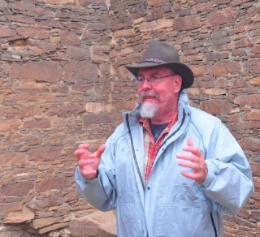
Paul Reed has been a Preservation Archaeologist with Archaeology Southwest since 2001. He is based in Taos, New Mexico and still works as the occasional Chaco Scholar at Salmon Ruins, New. Reed’s most recent writing is an edited book (with Gary M. Brown as co-editor) entitled Aztec, Salmon, and the Pueblo Heartland of the Middle San Juan, published in SAR Press’ Popular Series in 2018. He also served as editor (and author of several chapters) on Chaco's Northern Prodigies: Salmon, Aztec, and the Ascendancy of the Middle San Juan Region After AD 1100, published by the University of Utah Press (2008). Reed was also editor (and author of several chapters) of the three-volume, comprehensive report entitled Thirty-Five Years of Archaeological Research at Salmon Ruins, New Mexico published in 2006. His other books – The Puebloan Society of Chaco Canyon (2004) and Foundations of Anasazi Culture (published in 2000; as editor and author) have explored the origins of Puebloan culture and Chaco Canyon.
During the last six years, Reed has been working to protect the Greater Chaco Landscape from the effects of expanded oil-gas development associated with fracking in the Mancos Shale formation. Through a series of meetings and forums with public officials, Tribal leaders, various US Government agencies, and New Mexico’s Congressional delegation, Archaeology Southwest and its partners have focused on expanding protections to sites, traditional cultural places, and fragile landscapes in the greater San Juan Basin. The most recent effort on this front is to partner with the Pueblo of Acoma to complete a focused ethnographic study of Acoma’s connections to the Greater Chaco Landscape.
Among his other interests, Reed leads tours to Salmon and Aztec Ruins, Chaco Canyon, the Chuska Valley, and the Navajo Country, and gives public presentations on different topics in southwestern archaeology and history. Reed has conducted fieldwork and research in the Southwest for more than 30 years. From 1993 to 2001, Reed directed a roads archaeology research program for the Navajo Nation Archaeology Department, Farmington, New Mexico. Reed completed his Bachelor of Arts (1986) and Master of Arts (1989 in anthropology and archaeology) degree at New Mexico State University.

TOPIC

Protecting Greater Chaco: Where We Stand 2021

After four very long years, there is light at the end of the tunnel. The last three months have seen several positive developments as the new Biden administration took office. We now have a new Secretary of the Interior (Deb Haaland) who has put a high priority on protecting the Greater Chaco Landscape. Furthermore, the BLM and BIA have halted the planning process that was rushed in 2020 and announced that it will extend into 2022. My own research from 2020 in the 10-mile protection zone has revealed site clusters and communities that have yet to be protected by Federal action. In this presentation, I will discuss new developments and the future of protection around Chaco Canyon.

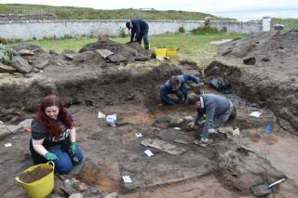

An effort is currently underway to build a historical timeline of events in the history of the Taos Archaeological Society. We need your help if you have records that date in the period September 1999 through February 2014. These dates range between the last completed history for the society and the earliest records archived on our web site.

The Taos Archaeological Society has operated for 34 years. At present documents we have accessible cover under 60 percent of that time. Old bulletins, meeting minutes, financial statements, member lists and other communications of the society will assist in this effort. Please do help if you can. You can send records directly to Paul McGuff (pmcguff@aol.com).

The Taos Archaeological Society is always looking for volunteers to participate in activities and volunteer as officers. Please contact taoscuba@hotmail.com for volunteer opportunities

Thank you for your continuing support of TAS.

A New Ceramic Analysis Committee Has been formed!!

Ceramic Sorting and Analysis is getting organized for a pilot project to have analysis conducted on a private take home individual basis to observe Covid-19.

Pot Creek Ceramic Sorting is still requesting volunteers to participate in processing out their Prehistoric collections. Contact Mark Henderson for more information. markscotthenderson@gmail.com

Join the Sherders Zoom meetings each Wednesday at 9am to get updated on the activities going forward.

Zoom Id Number Meeting ID: 878 3989 2686

Taos Black on White
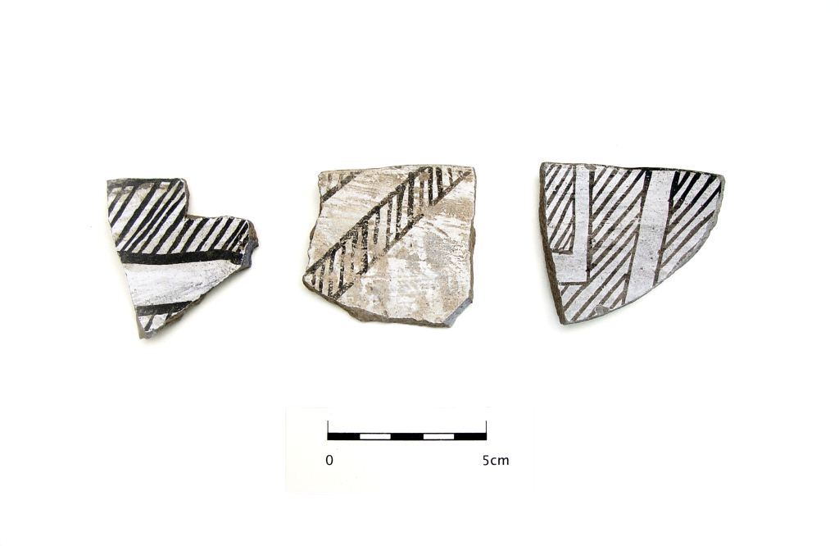
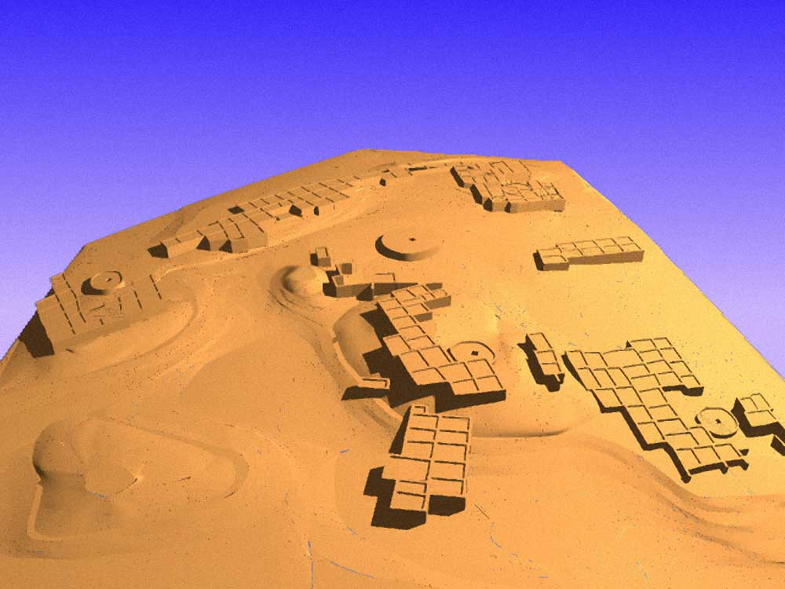

Pot Creek Pueblo 1320 AD

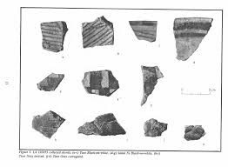
Slate of TAS Officer Elected for 2021-2022
February 1, 2021 until January 31, 2022

Phil Alldritt President
Nancy Colvert Vice President
Debbie Espie Secretary
Chris Ellis Treasurer
Anita Briscoe At Large
Cassandra Keyes At Large
Non- Officer Position
Katheryn Ritter Webmaster

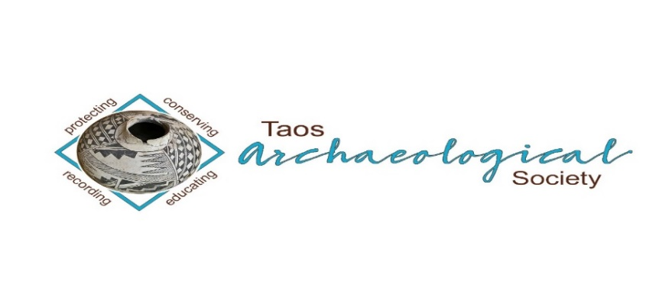
The Taos Archaeological Society is pleased to announce we are hosting the Annual Meeting of ASNM. The Conference will take place May 6-8, 2022 next Spring. TAS is looking for volunteers to participate in helping Saturday May 7. The Meeting theme will be “Taos at the Crossroads of Trade”.

Register on the TAS website coming soon at taosarch.org

Interesting lectures, Field Trips, Steve Lekson keynote speaker and Banquet Dinner. Burro loading demonstration,
Silent Auction.

Contact Phil Alldritt at taoscuba@hotmail.com to participate as a volunteer.
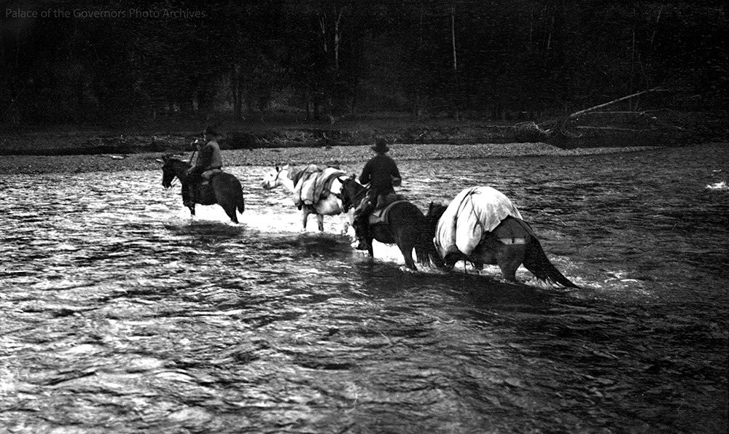

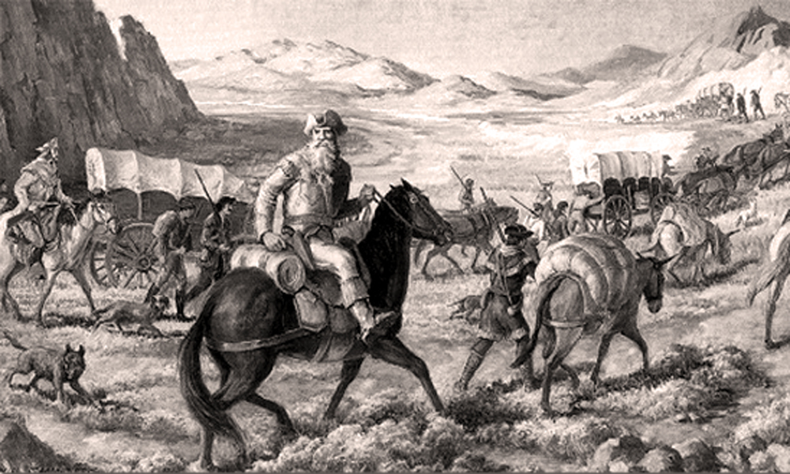

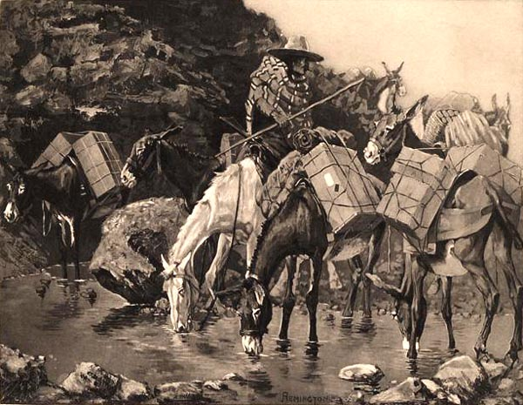

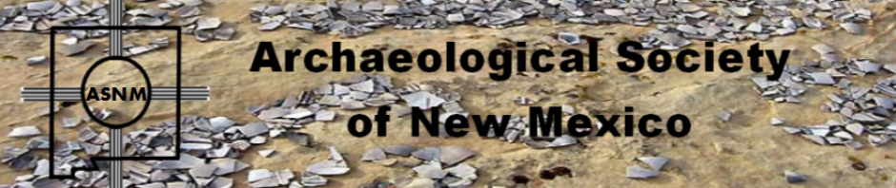

Budget information for 2020 for the Taos Archaeological Society is now posted on the website.

2021 Membership Dues can be paid now!!!!

The Taos Archaeological Society is offering Lifetime Membership with the contribution of $500.00 per individual anytime up until December 31, 2021. Take advantage of this Tax Deductible opportunity and help TAS fund our mission!! The Lifetime Membership will include the Member plus 1 additional family member.
TAS
PO Box 143
Taos, NM 87571

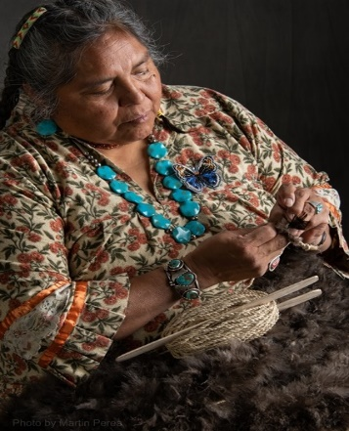
THIS ACTIVITY Has Been Rescheduled for Saturday JUNE 11, 2022
Members already paid are signed up!!!

To the Membership of the Taos Archaeological Society,

On Saturday, June 11 ,2022, Mary Motah will conduct a basket and sandal weaving demonstration and hands on workshop for TAS members. The workshop will take place at the Kit Carson Board Room on Cruz Alta Road from 10am-4pm.

The participation is limited to 15 persons. This will fill quickly. Registration based on first 15 payments received. Please include your email to receive a confirmation.

If you miss out we will do this in an ongoing basis. The second 15 payments received will be confirmed to participate in the June 2023 workshop.

The participation fee is $15.00 check or money order made out to Mary Motah. It should be mailed to

Phil Alldritt
PO Box 659
Arroyo Hondo, NM 87513

First 15 deposits received are confirmed. No one is confirmed until payment is received.

Participants should bring a small pocket knife, wear shorts, bring brownbag lunch and drink.

In case of cancellation and you request a refund contact me here.

Thank you for your support and participation in the TAS activities!!

STAND BY FOR UPDATES FOR
WINTER POT LUCK

TAKING RESERVATIONS FOR SPRING 2021!!!!!
The Taos Archaeological Society is Funding trips for students to The Mesa Prieta Petroglyph Project!! Trips coming up in Spring 2022!!! COVID PERMITTING!!!
Contact Phil Alldritt at taoscuba@hotmail.com

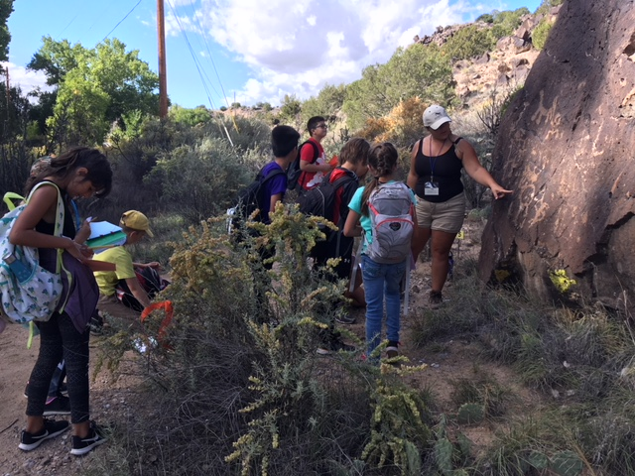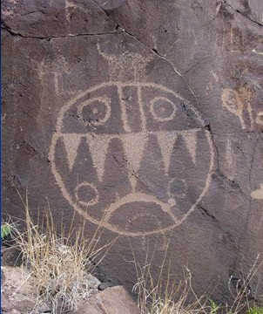

TAS is looking for Members to form an Education Committee who will promote and facilitate communication with teachers and schools to advance our bus trip programs!! To participate in this very successful effort contact Phil Alldritt at taoscuba@hotmail.com
Thank you!!!

Upcoming Trips
Trip reservations are first come first serve all trips have limited space. No reservation is confirmed until deposits have been made. Watch for future trips on the website!!!
Thank you! COVID PERMITTING!!!
All TAS trips may be sign up for by TAS Members who are Active Members in Good Standing. Persons wanting to participate should become Members by mailing 30.00 to
TAS PO Box 143 Taos, NM 87571 Thank you!!!\
Next Speaker
May 10, 2021
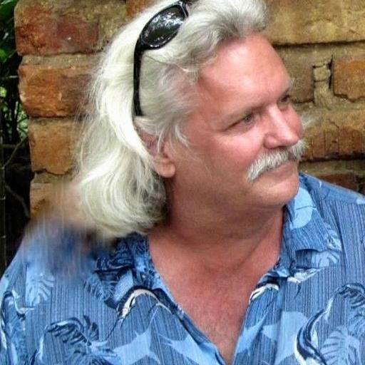
Phil Alldritt is an Instructor of Anthropology and Archaeology at the University of New Mexico -Taos. He worked on the Cuello Belize Archaeological Project and the Nohmul Archaeological Project in 1987 and 1989. He excavated at Quim Chi Hilan in 1993 in on the Projecto de Arqueologia de Petexbatun in Guatemala.. He has been a professional guide for Maya archaeological sites in Belize and Guatemala since 1985. He has been a Belizean National Tour Guide Instructor for the Belizean Government. He has a Master's Degree in Latin American Studies from the University of Arizona.
Olmec and the Maya Connection
Archaeology on the Gulf Coast of Mexico is progressing and making new discoveries about who the Olmec were and using Lidar hundreds of new sites are being located. Meanwhile, hundreds of miles away excavations at Ceibal Guatemala are revealing the Maya were building Preclassic structures and developing complex quickly at the same time the Olmec society was still flourishing. Where did glyph writing begin? Who was worshiping Jaguars first? Did the Maya migrate from somewhere else or develop their cities from a local Archaic population of hunter-gatherers? We will investigate these connections.

Exciting speakers coming all next year 2021and 2022!!!! Watch for the bulletins beginning again in September online at taosarch.org for announcements!!!!

.

.

