The Taos Archaeological Society
November 12, 2019

Tonight’s Speaker

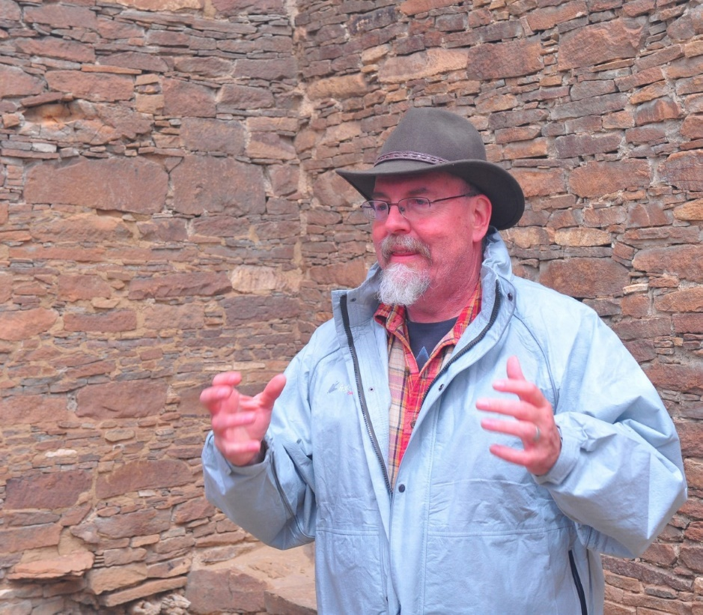
Paul F. Reed

Paul Reed has been a Preservation Archaeologist with Archaeology Southwest since 2001. He is based in Taos, New Mexico and still works as the occasional Chaco Scholar at Salmon Ruins, New. Reed’s most recent writing is an edited book (with Gary M. Brown as co-editor) entitled Aztec, Salmon, and the Pueblo Heartland of the Middle San Juan, published in SAR Press’ Popular Series in 2018. He also served as editor (and author of several chapters) on Chaco's Northern Prodigies: Salmon, Aztec, and the Ascendancy of the Middle San Juan Region After AD 1100, published by the University of Utah Press (2008). Reed was also editor (and author of several chapters) of the three-volume, comprehensive report entitled Thirty-Five Years of Archaeological Research at Salmon Ruins, New Mexico published in 2006. His other books – The Puebloan Society of Chaco Canyon (2004) and Foundations of Anasazi Culture (published in 2000; as editor and author) have explored the origins of Puebloan culture and Chaco Canyon.
During the last six years, Reed has been working to protect the Greater Chaco Landscape from the effects of expanded oil-gas development associated with fracking in the Mancos Shale formation. Through a series of meetings and forums with public officials, Tribal leaders, various US Government agencies, and New Mexico’s Congressional delegation, Archaeology Southwest and its partners have focused on expanding protections to sites, traditional cultural places, and fragile landscapes in the greater San Juan Basin. The most recent effort on this front is to partner with the Pueblo of Acoma to complete a focused ethnographic study of Acoma’s connections to the Greater Chaco Landscape.
Among his other interests, Reed leads tours to Salmon and Aztec Ruins, Chaco Canyon, the Chuska Valley, and the Navajo Country, and gives public presentations on different topics in southwestern archaeology and history. Reed has conducted fieldwork and research in the Southwest for more than 30 years. From 1993 to 2001, Reed directed a roads archaeology research program for the Navajo Nation Archaeology Department, Farmington, New Mexico. Reed completed his Bachelor of Arts (1986) and Master of Arts (1989 in anthropology and archaeology) degree at New Mexico State University.

Topic
Aztec, Salmon, and the Middle San Juan as a Pueblo Heartland

The Middle San Juan region of northwestern New Mexico is often misunderstood regarding its Puebloan history. Falling between the better-known Pueblo cultural centers at Chaco Canyon and Mesa Verde, the ancient Aztec and Salmon communities rarely attract deserved attention. Research at these Puebloan centers over the last 100, and particularly, the last 20 years has revealed a unique and outstanding record of innovation and creativity, as well as large numbers of Pueblo-affiliated peoples. In this talk, I will highlight the special nature of the ancient Puebloan use of the Middle San Juan region. I will also provide a brief update on our efforts to protect the Greater Chaco Landscape from oil-gas development.

Pot Creek Ceramic Sorting is still requesting volunteers to participate in processing out their Prehistoric collections. Wednesdays at 9:00am at the SMU Laboratory. Contact Mark Henderson for more information. markscotthenderson@gmail.com

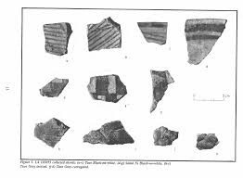

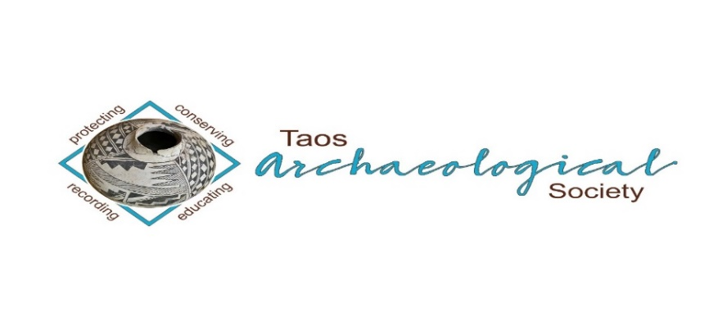
The Taos Archaeological Society is pleased to announce we are hosting the Annual Meeting of ASNM. The Conference will take place May 8-10, 2020 next Spring. TAS is looking for volunteers to participate in helping Saturday May 9. The Meeting theme will be “Taos at the Crossroads of Trade”.

Register on the TAS website now at taosarch.org

Interesting lectures, Field Trips, Steve Lekson keynote speaker and Banquet Dinner. Burro loading demonstration,
Silent Auction.

Contact Phil Alldritt at taoscuba@hotmail.com to participate as a volunteer.
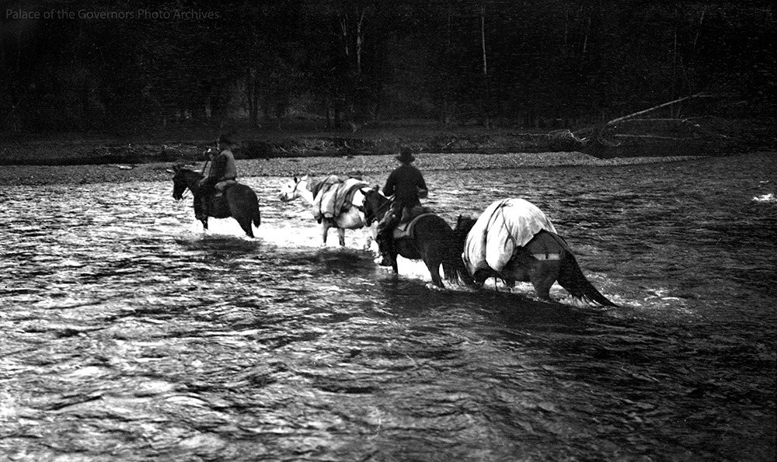

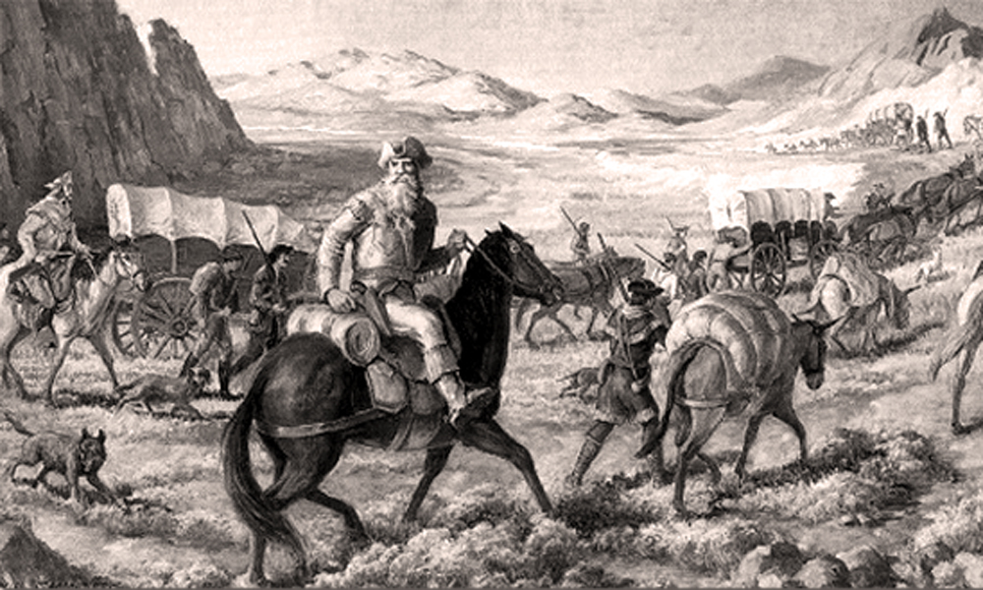

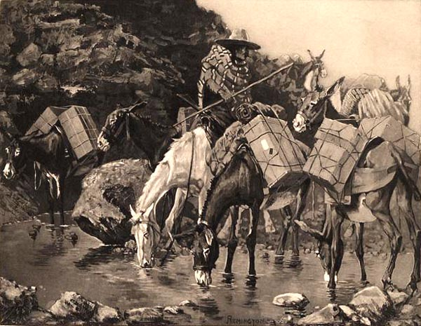

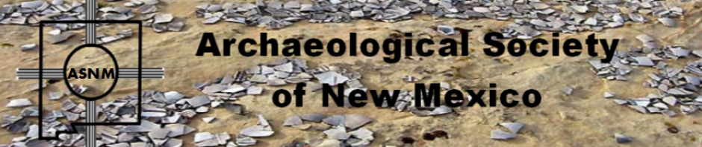

The Taos Archaeological Society is offering Lifetime Membership with the contribution of $500.00 per individual anytime up until December 31, 2019. Take advantage of this Tax Deductible opportunity and help TAS fund our mission!! The Lifetime Membership will include the Member plus 1 additional family member.
TAS
PO Box 143
Taos, NM 87571

The Taos Archaeological Society, in cooperation with Carson National Forest will participate in archaeological testing of a rock shelter site in Valle Vidal Summer of 2020. We will be posting updated information soon to Members.

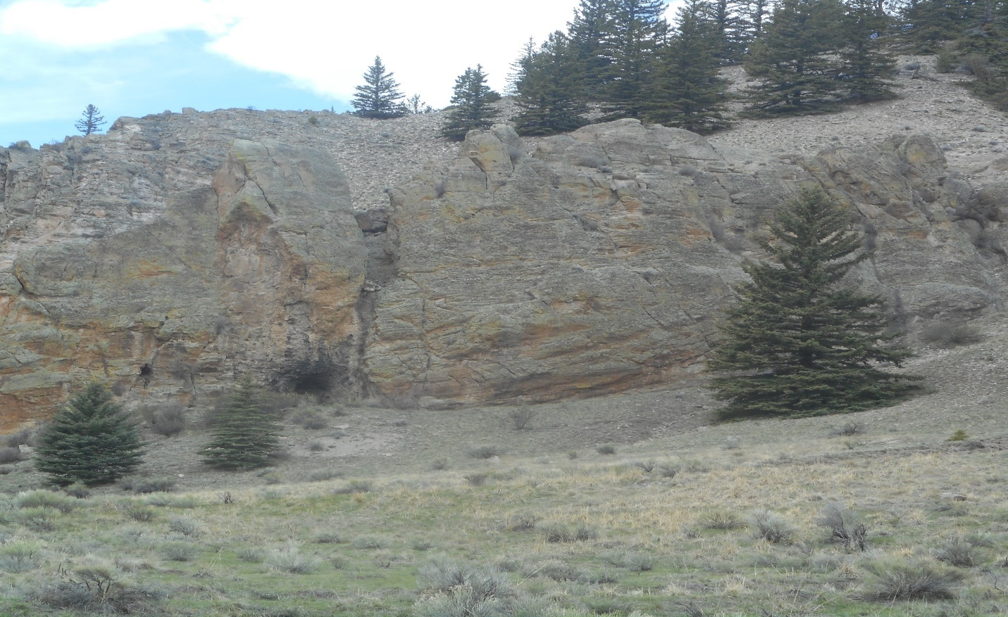

We excavated and surveyed this area for a week August 5-9, 2019 and recorded two hearths and many artifacts. Three new sites were also recorded. We collected lithics including obsidian and 5 ceramics. Also, in the excavation we found an Archaic projectile dart San Pedro variety (see photo below (circa 1500 BC). Great group of archaeology techs and volunteers from TAS.
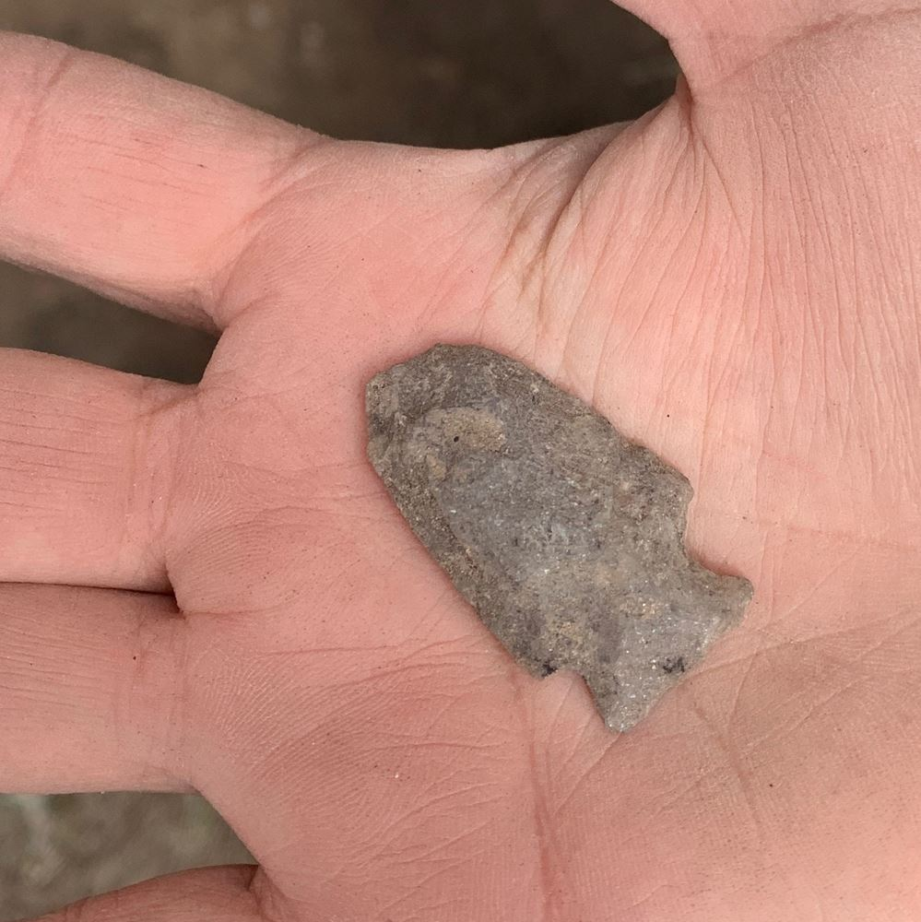
Archaic Dart Armijo Side Notched circa 5000 BC

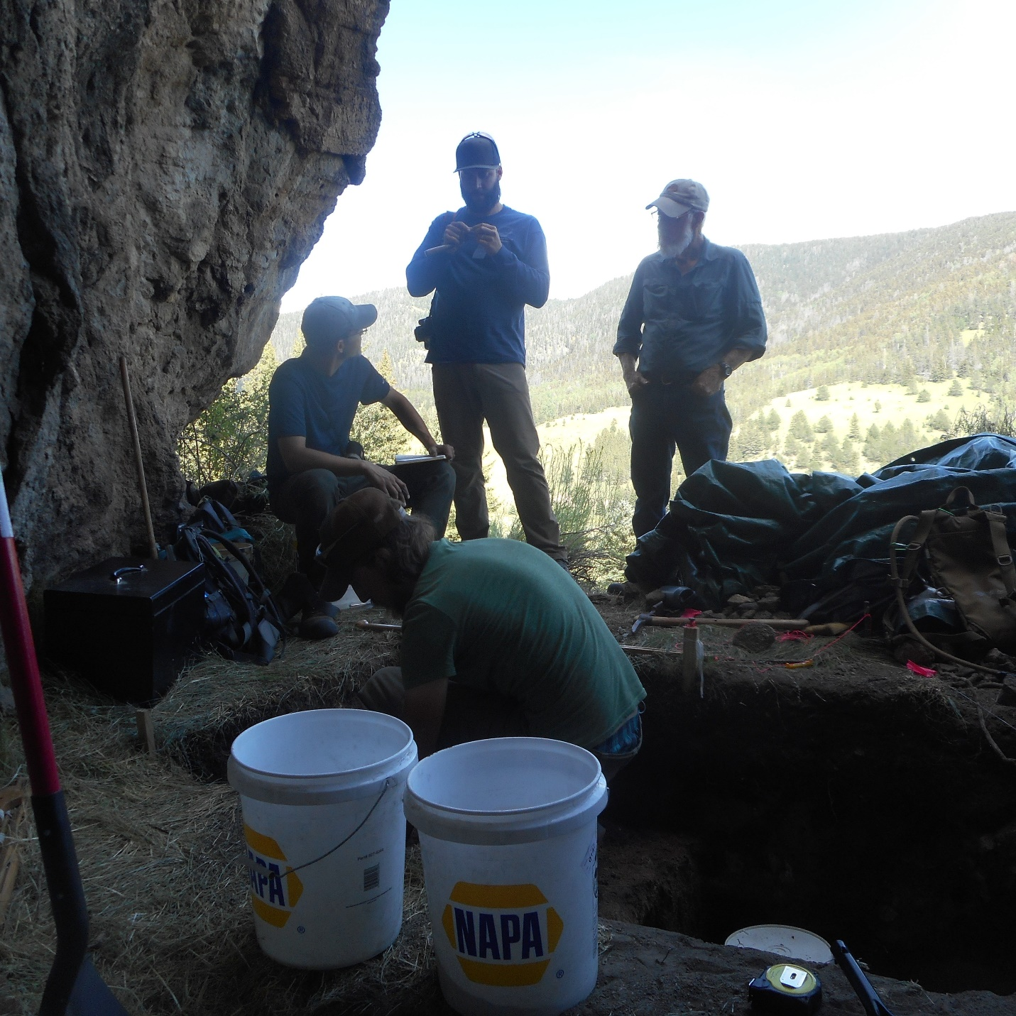

La Cueva excavation underway

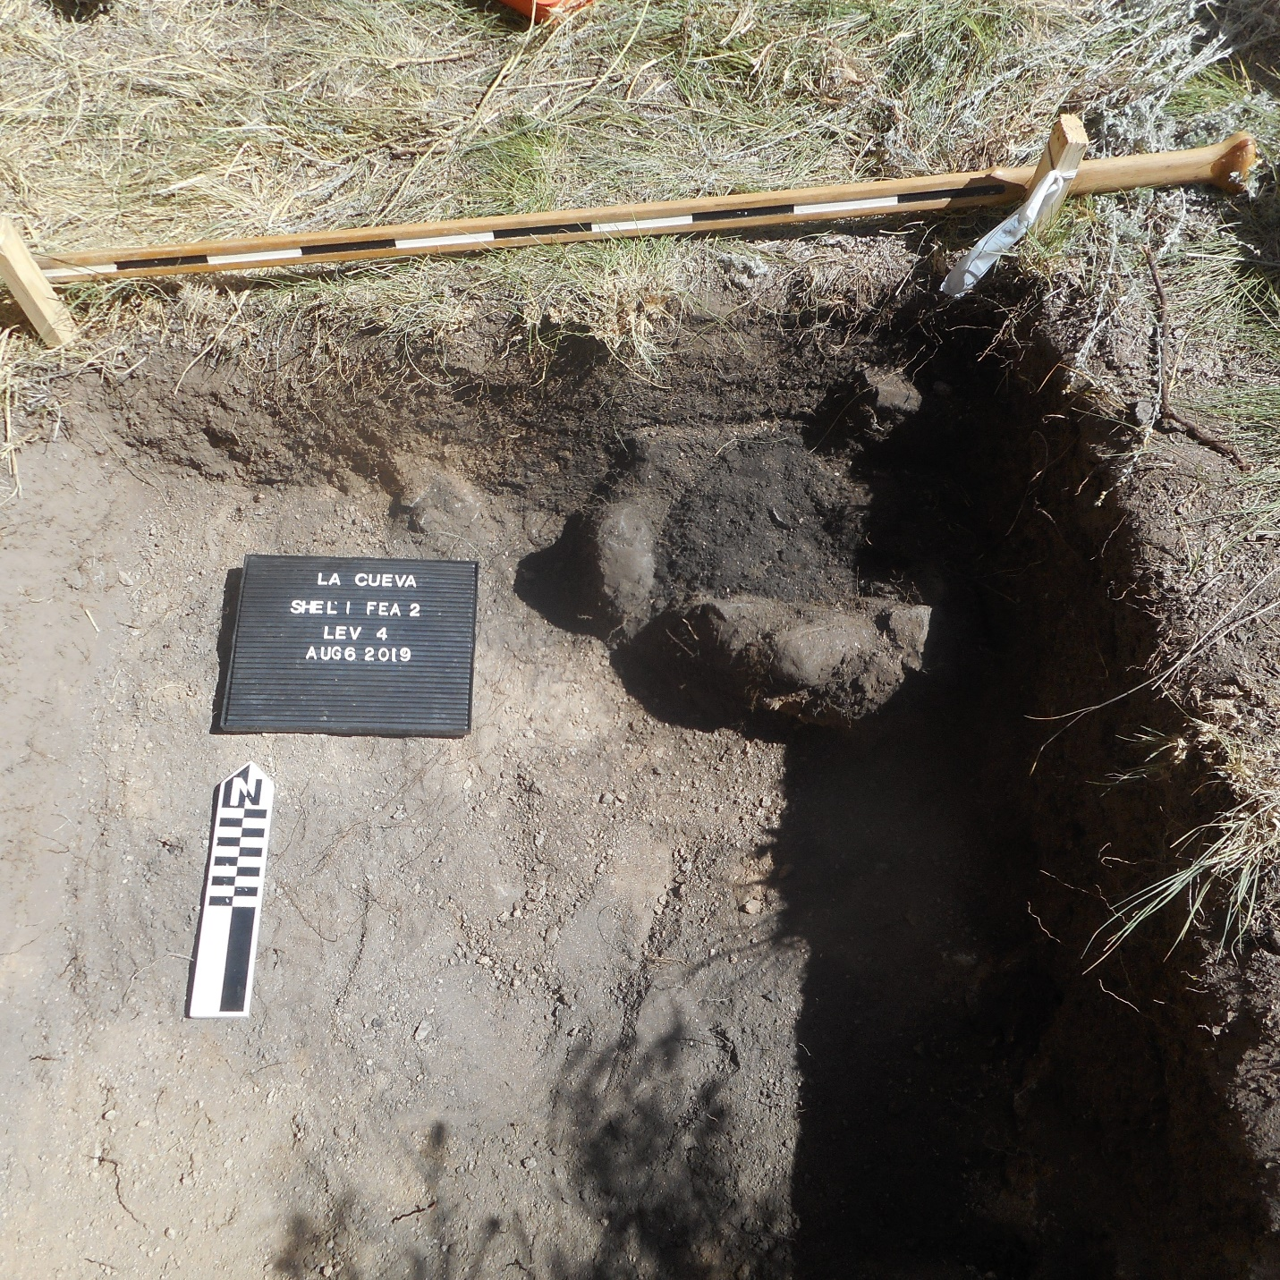

La Cueva Feature 2 Thermal Feature

Winter POT LUCK
COMING SOON!!!
December 7, 2019

St. James Church
Gusdorf Road
500pm-700pm
Bring your favorite Wintertime Dish to Share!!!
Wine and Lemonade provided.

The Taos Archaeological Society is in part Funding trips for students to The Mesa Prieta Petroglyph Project!! Trips coming up this Spring 2020!!!
Contact Phil Alldritt at taoscuba@hotmail.com

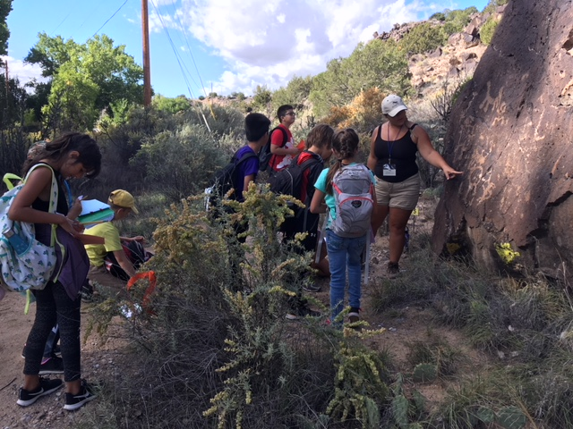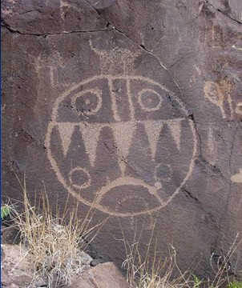

TAS is looking for Members to form an Education Committee who will promote and facilitate communication with teachers and schools to advance our bus trip programs!! To participate in this very successful effort contact Phil Alldritt at taoscuba@hotmail.com
Thank you!!!

TAS is also looking for Members to participate in organizing TAS archives from 2000-Present. We are requesting that any Members who have photographs from TAS trips and any archival materials to contact Phil Alldritt at taoscuba@hotmail.com. Thank you!!!!!

Upcoming Trips
Trip reservations are first come first serve all trips have limited space. No reservation is confirmed until deposits have been made. Watch for future trips on the website!!!
Thank you!
All TAS trips may be sign up for by TAS Members who are Active Members in Good Standing. Persons wanting to participate should become Members by mailing 30.00 to
TAS PO Box 143 Taos, NM 87571 Thank you!

May 2020
Chaco Canyon 3 Day Trip with Paul Reed
towerkiva@yahoo.com for information

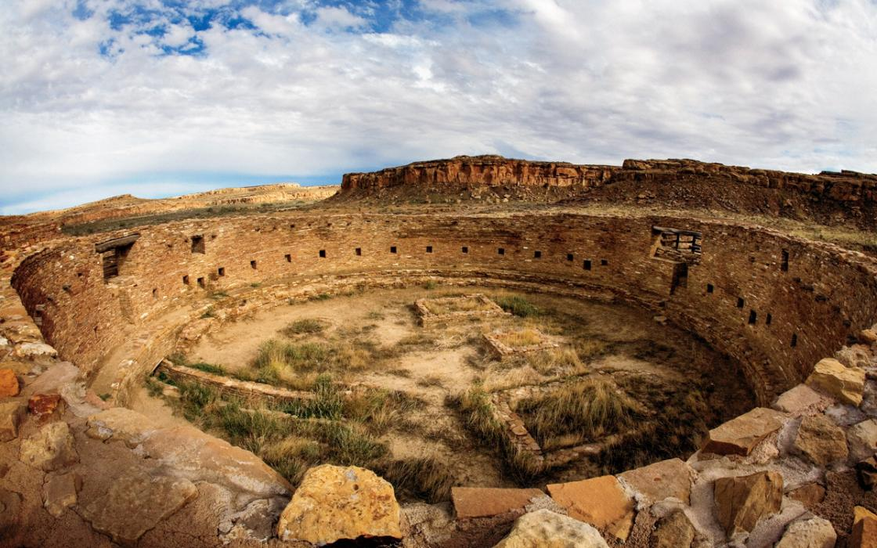
Chaco Canyon Aztec Ruins and Salmon Ruins
15 persons maximum No camping required But is an option.
May 15-17, 2020 3 Day Trip Guide: Paul Reed towerkiva@yahoo.com
May 15 May 17
700am Depart Bloomfield
Depart from Taos Visit Twin Angels Chaco Outlier and Great North Road
Visit Salmon Ruins Depart Bloomfield
Lunch Arrive Taos
Visit Aztec Ruins
Overnight Bloomfield
May 16
Visit Chaco Canyon Museum
All day Chaco Canyon Tour
Visit Chaco Museum
Transfer to Bloomfield for Overnight

***Participants responsible for arranging hotels, transportation and food, Good walking shoes required. Sunscreen, rain gear, backpack and water.

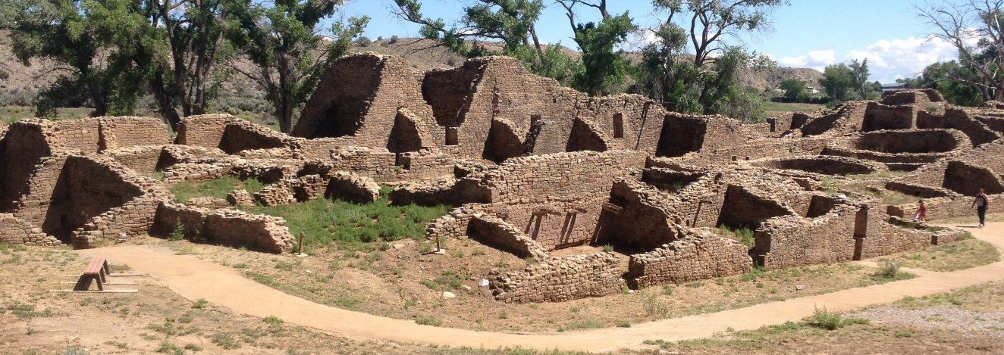
Aztec Ruins

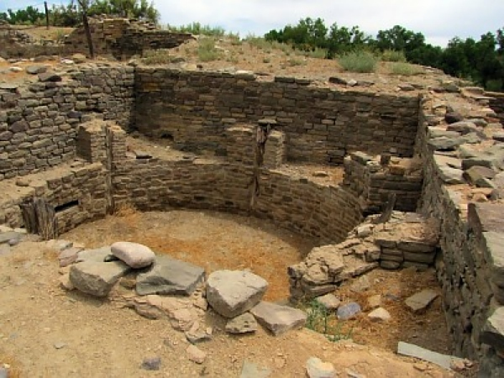
Salmon Room Block

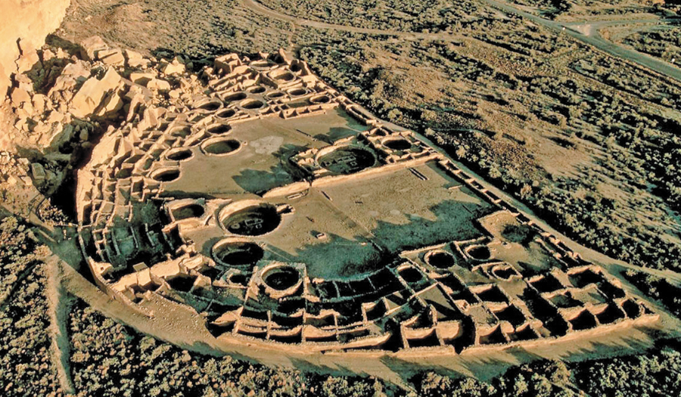
Pueblo Bonito

Next Speaker January 14, 2020

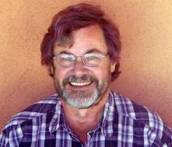
Delafield Dubois

Del has spent a lifetime exploring the wilds by foot, ski, and boat. He has floated over 30,000 river miles, including over 20 years as a commercial guide and co-owner of Los Rios River Runners. Growing up in the woods less than a mile from Walden Pond, then living on the edge of the mind-boggling sprawl of Southern California, he understands the importance of land conservation. With a degree in anthropology and Latin American history, he has worked as an archeologist for the Carson National Forest and a River Ranger for the Bureau of Land Management. He has also served on the Boards of Taos Search and Rescue and the Albuquerque Mountain Rescue Council. Photographer, Archeologist, Park Ranger, story teller and adventurer on land and water.

Topic
Tonight’s lecture will present a program about the 50 plus constructed trails
within the Rio Grande Gorge. Who made them, how and why,
along with stories and photos from 47 years
of exploring the canyon ,
Photographer, Archeologist, Park Ranger, story teller
and adventurer on land and water,

.

