The Taos Archaeological Society
November 9, 2021
5:30pm (Sign in by 5:25pm) Zoom ID 545 842 9500

Tonight’s Speaker
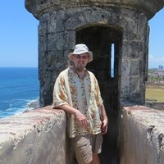
Matt Barbour

Mining Camps of Cookes Peak
The mountain northeast of Deming, known as Cookes Peak, was once a flourishing industrial
center. Miners in the late 1800s established three major camps in the area: Cooks Town, Hadley Town, and Jose Town. These communities expanded and contracted with the price of silver until the area was largely abandoned in the mid-twentieth century. Traces of the camps are evident on the mountainside today and their legacy remains an important part of history to the City of Deming and the people of Luna County.
Corn & Cotton: Archaic Life along the Mimbres River
In 2011, the Office of Archaeological Studies conducted data recovery on an archaeological site along the Mimbres River, just north of Deming, New Mexico. These efforts resulted in the documentation of 25 features and the collection of 2,091 artifacts and samples. Analytical results suggest that principal occupation of the site occurred during the Late Archaic/Early Agricultural Period with an emphasis on corn and cotton production. This presentation will provide a brief overview of the archaeological investigations while substantiating and improving upon our knowledge of early human habitation in the Mimbres Basin.

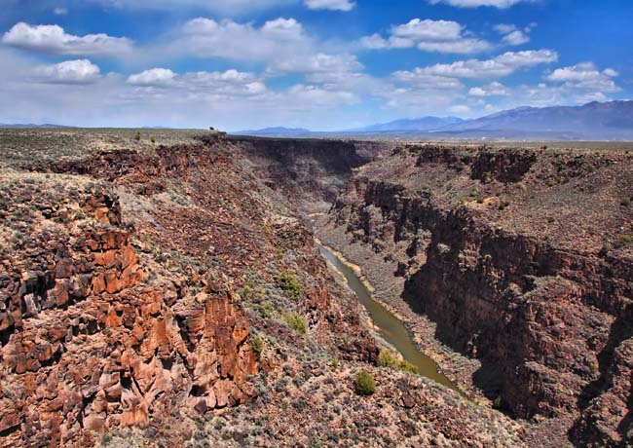
On September 25 and 26 TAS volunteers, in partnership with Natalie Sanford from the Bureau of Land Management Taos Field Office, began preliminary survey and artifact documentation of the Newman Dome archaeological site. This is planned as a collaborative multi-year project between TAS and the BLM and is expected to continue next September. The TAS volunteers included Cassandra Keyes (Newman Dome Subcommittee Chairperson), Tim Viereck, Joel Clark, and Bob and Sara Blair. Natalie Sanford was Field Supervisor.
Newman Dome was used by indigenous groups for thousands of years as a lithic procurement site. The material that these folks were collecting is known as dacite- a black volcanic rock that is similar to basalt- which they used for making projectile points and other tools.
The first day of fieldwork was dedicated to pedestrian survey, artifact identification, and flagging of tools. Over 50 tools were identified and flagged and were recorded on the second day. Over the course of the weekend, volunteers not only learned how to identify bifacially worked artifacts, various projectile point types, and ground stone artifacts, but also learned how to measure, describe, and photograph artifacts according to scientific standards!
Dr. Steve Shackley, professor emeritus of UC-Berkley, joined the group on Sunday to provide an overview of the geologic history of the Taos Plateau and the formation of Newman’s Dome with an emphasis on why this particular feature was targeted for tool stone.
The BLM will begin working on an initial report during the winter.
Very many thanks to Bob and Sara Blair for providing food for the crew and for organizing first aid and logistical support and to Mark Henderson for providing equipment.

Message for the Members of TAS:

Hope you are having a great fall and all getting vaccinations so we can begin to have face to face meetings as soon as possible. As you are probably beginning to realize vaccinations will be REQUIRED to participate in TAS activities for 2022. Not because of our mandates , but because of facilities and service providers we would like to use for future activities. As of now, we will continue to have Zoom lectures until January 2022.

We are mostly restricted as the Kit Carson is not allowing any groups to meet in person yet. We will keep you updated when that changes. This, of course, is their decision.

Please go to You Tube and Enter Taos Archaeological Society for recorded Lectures you may have missed.

Until then, stay healthy and safe,

Thank you and we will see you all soon.

The TAS Officers

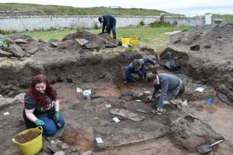

An effort is currently underway to build a historical timeline of events in the history of the Taos Archaeological Society. We need your help if you have records that date in the period September 1999 through February 2014. These dates range between the last completed history for the society and the earliest records archived on our web site.

The Taos Archaeological Society has operated for 34 years. At present documents we have accessible cover under 60 percent of that time. Old bulletins, meeting minutes, financial statements, member lists and other communications of the society will assist in this effort. Please do help if you can. You can send records directly to Paul McGuff (pmcguff@aol.com).

TAS, SMU-Taos and the Picuris Pueblo in Partnership!!!

A New Ceramic Analysis Committee Has been formed!!

Ceramic Sorting and Analysis is getting organized for a pilot project to have analysis conducted on a private take home individual basis to observe Covid-19.

Picuris Analysis Ceramic Sorting is still requesting volunteers to participate in processing out their Prehistoric collections. Contact Mark Henderson for more information. markscotthenderson@gmail.com

Sherder’s ZOOM MEETINGS temporarily suspended.

Join the Sherders Zoom meetings each Wednesday at 9am to get updated on the activities going forward.

Zoom Id Number Meeting ID: 878 3989 2686

Taos Black on White
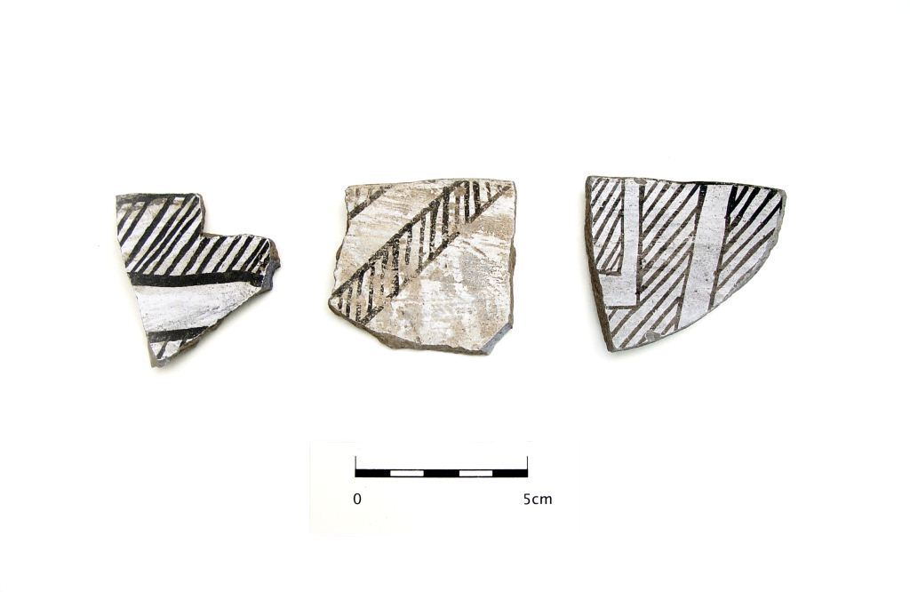
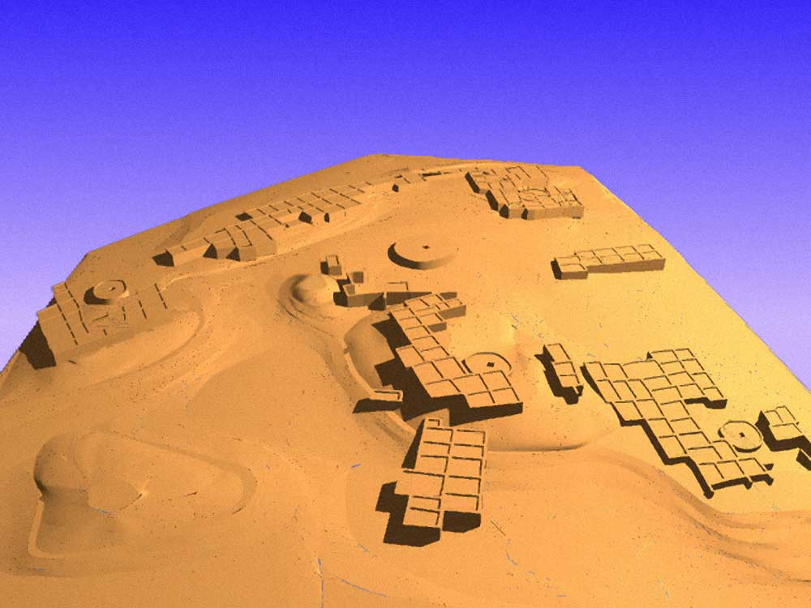

Pot Creek Pueblo 1320 AD

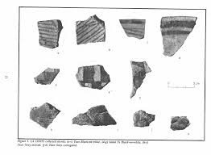
Slate of TAS Officer Elected for 2021-2022
February 1, 2021 until January 31, 2022

Phil Alldritt President
Cassandra Keyes Vice President
Debbie Espie Secretary
Chris Ellis Treasurer
Anita Briscoe At Large

Webmaster (Non Officer position)
Phil Alldritt

The Current Committee Chairs Are as follows:

Education Committee Anita Briscoe

Fieldwork Committee Gary Grief

Newman Dome Subcommittee Cassandra Keyes

Picuris Ceramic Analysis Committee Mark Henderson

Blumenshein Ceramic Analysis Committee For Charter Development
Kurt Weidler/ Jeff Boyer/Becky Quintana/Paul McGuff

Program Committee Cassandra Keyes, Debbie Dean, Phil Alldritt

Trip Committee Paul Reed , Phil Alldritt

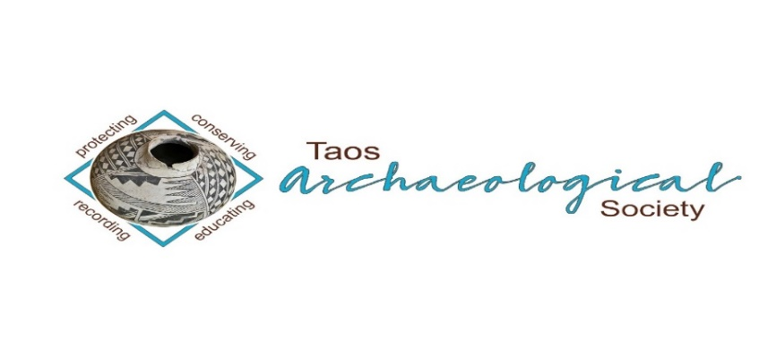
The Taos Archaeological Society is pleased to announce we are hosting the Annual Meeting of ASNM. The Conference will take place May 6-8, 2022 next Spring. TAS is looking for volunteers to participate in helping Saturday May 7. The Meeting theme will be “Taos at the Crossroads of Trade”.

Register on the TAS website coming soon at taosarch.org

Interesting lectures, Field Trips, Steve Lekson keynote speaker and Banquet Dinner. Burro loading demonstration,
Silent Auction.

Contact Phil Alldritt at taoscuba@hotmail.com to participate as a volunteer.
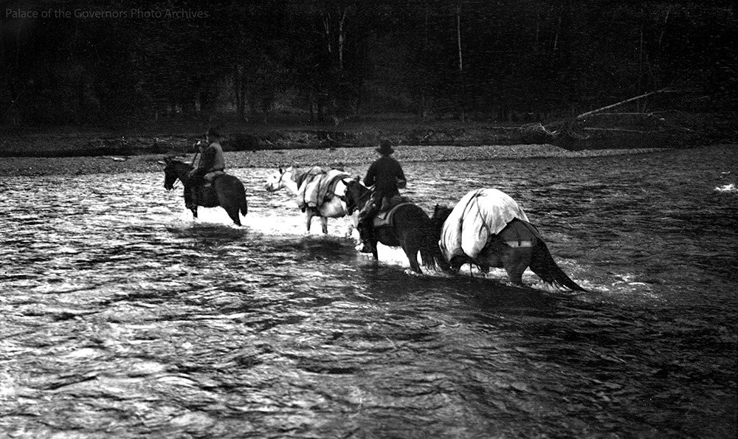

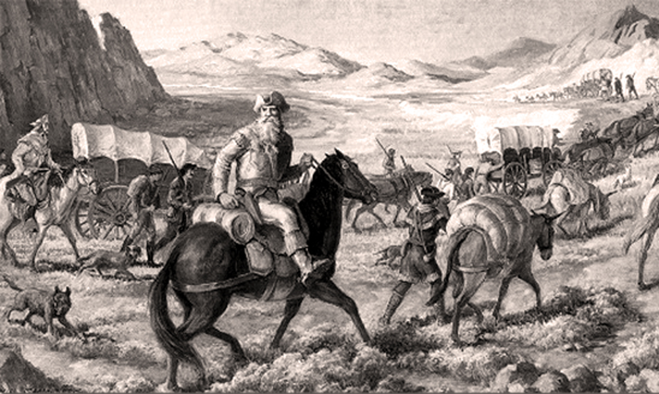

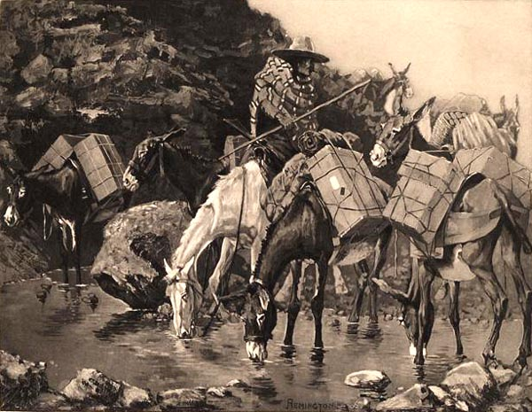

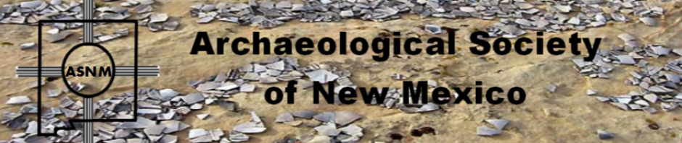

Budget information for 2021 for the Taos Archaeological Society is now posted on the website.

2022 Membership Dues can be paid now!!!!

The Taos Archaeological Society is offering Lifetime Membership with the contribution of $500.00 per individual anytime up until December 31, 2021. Take advantage of this Tax Deductible opportunity and help TAS fund our mission!! The Lifetime Membership will include the Member plus 1 additional family member.
TAS
PO Box 143
Taos, NM 87571

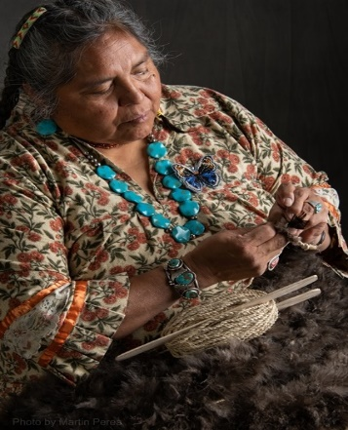
THIS ACTIVITY Has Been Rescheduled for Saturday JUNE 11, 2022
Members already paid are signed up!!!

To the Membership of the Taos Archaeological Society,

On Saturday, June 11 ,2022, Mary Motah will conduct a basket and sandal weaving demonstration and hands on workshop for TAS members. The workshop will take place at the Kit Carson Board Room on Cruz Alta Road from 10am-4pm.

The participation is limited to 15 persons. This will fill quickly. Registration based on first 15 payments received. Please include your email to receive a confirmation.

If you miss out we will do this in an ongoing basis. The second 15 payments received will be confirmed to participate in the June 2023 workshop.

The participation fee is $15.00 check or money order made out to Mary Motah. It should be mailed to

Phil Alldritt
PO Box 659
Arroyo Hondo, NM 87513

First 15 deposits received are confirmed. No one is confirmed until payment is received.

Participants should bring a small pocket knife, wear shorts, bring brownbag lunch and drink.

In case of cancellation and you request a refund contact me here.

Thank you for your support and participation in the TAS activities!!

STAND BY FOR UPDATES FOR
FUTURE POT LUCKS (COVID PERMITTING)

TAKING RESERVATIONS FOR SPRING 2022!!!!!
The Taos Archaeological Society is Funding trips for students to The Mesa Prieta Petroglyph Project!! Trips coming up in Spring 2022!!! COVID PERMITTING!!!
Contact Phil Alldritt at taoscuba@hotmail.com

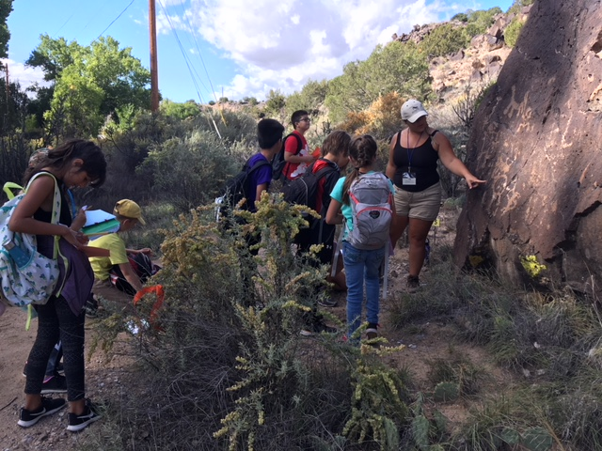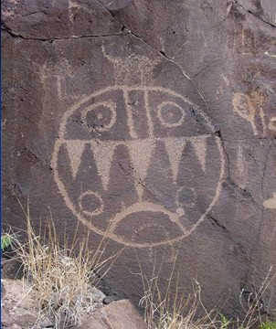

TAS is looking for Members to form an Education Committee who will promote and facilitate communication with teachers and schools to advance our bus trip programs!! To participate in this very successful effort contact Phil Alldritt at taoscuba@hotmail.com
Thank you!!!

Upcoming Trips
Trip reservations are first come first serve all trips have limited space. No reservation is confirmed until deposits have been made. Watch for future trips on the website!!!
Thank you! COVID PERMITTING!!!
All TAS trips may be sign up for by TAS Members who are Active Members in Good Standing. Persons wanting to participate should become Members by mailing 30.00 to
TAS PO Box 143 Taos, NM 87571 Thank you
Next Speaker
December 14, 2021
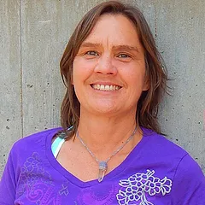
Carrie Leven
Carrie Leven has worked as an archaeologist on the Carson National Forest in Taos since moving back to New Mexico in 1993. One of her special areas of interest is the archaeology of the Valle Vidal and its role as a hunting grounds and travel way between the Rio Grande Valley and the Plains prior to and after European arrival.

TOPIC - Carrie has been researching and finding evidence of the settlement and exploitation of the Mexican Land Grants -- including the busted mining boomtown of LaBelle on the Sangre de Cristo Land Grant on the west side of the Valle Vidal, and the railroad logging settlement at Ponil Park on the Maxwell Land Grant on the east side.

Carrie will show slides of archaeological sites and talk about the history and land use of this unique portion of the Questa Ranger District that is hidden along the high-country road that crosses the Sangre de Cristo Mountains between Costilla and Cimarron, New Mexico

Exciting speakers coming all next year in 2022!!!! Watch for the bulletins beginning again in January online at taosarch.org for announcements!!!!

.

.

