The Taos Archaeological Society
October 8, 2019

.Tonight’s Speaker
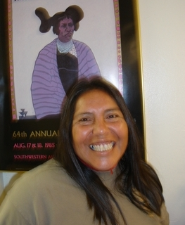
Mary Comanche Weahkee
I come to archaeology with a keen interest in the field and a varied range of life experiences. As a member of Santa Clara Pueblo and the Comanche Nation, I have both Southwestern and Plains tribal affiliations. At Santa Clara Pueblo I lived with my grandparents until the age of six, when, like many Pueblo families from my village, my family decided to seek new opportunities in the city. Growing up in Santa Fe Springs, California, I got a good education and went on to Cal State University, Fullerton, where I was awarded an athletic scholarship to play volleyball. I was also fortunate enough to play two years on the United States national team. In 1983 I moved back home to New Mexico, taught physical education classes, and coached at Santa Fe Indian School, Pojoaque High School, and Santa Fe PrepMy interest in archaeology began in 1992 when working with Nambe Pueblo Tours as a tour guide during the summers. I discovered that I had a natural curiosity about where my people came from. In March 2006 Steve Lentz hired me to help excavate the Civic Center in Santa Fe. Since then it has been just a pleasure working and learning archaeology with OAS's knowledgable staff. I've also enjoyed giving yucca-fiber production demonstrations with Eric Blinman and Chuck Hannaford as part of the OAS education outreach program, and working with Steve Post as an assistant guide during the Chiles & Sherds event. Recently I had the opportunity to go out on mine surveys with Yvonne Oakes and Dorthy Zamora in Raton. I am grateful for all the experiences I have had and new friends I have made here at OAS.

Topic

Comanche Horses and Petroglyphs in the Taos Area

Pot Creek Ceramic Sorting is still requesting volunteers to participate in processing out their Prehistoric collections. Wednesdays at 9:00am at the SMU Laboratory. Contact Mark Henderson for more information. markscotthenderson@gmail.com
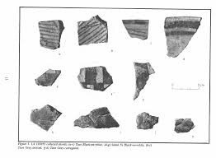

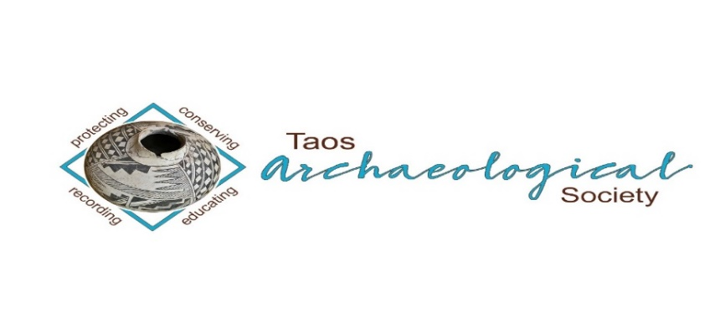
The Taos Archaeological Society is pleased to announce we are hosting the Annual Meeting of ASNM. The Conference will take place May 8-10, 2020 next Spring. TAS is looking for volunteers to participate in helping Saturday May 9. The Meeting theme will be “Taos at the Crossroads of Trade”.

Register on the TAS website now at taosarch.org

Interesting lectures, Field Trips, Steve Lekson keynote speaker and Banquet Dinner. Burro loading demonstration,
Silent Auction.

Contact Phil Alldritt at taoscuba@hotmail.com to participate as a volunteer.
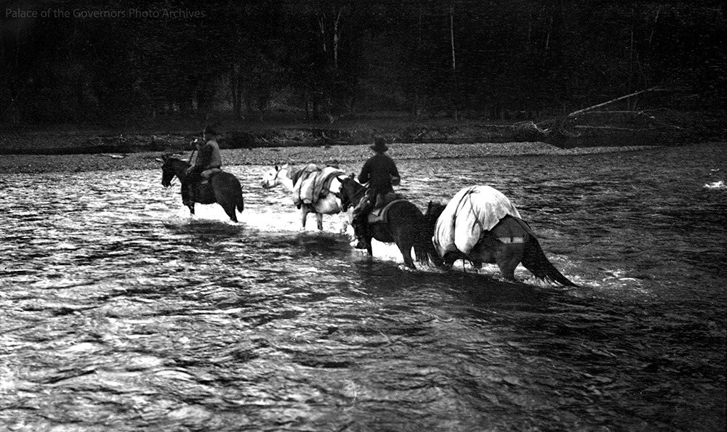

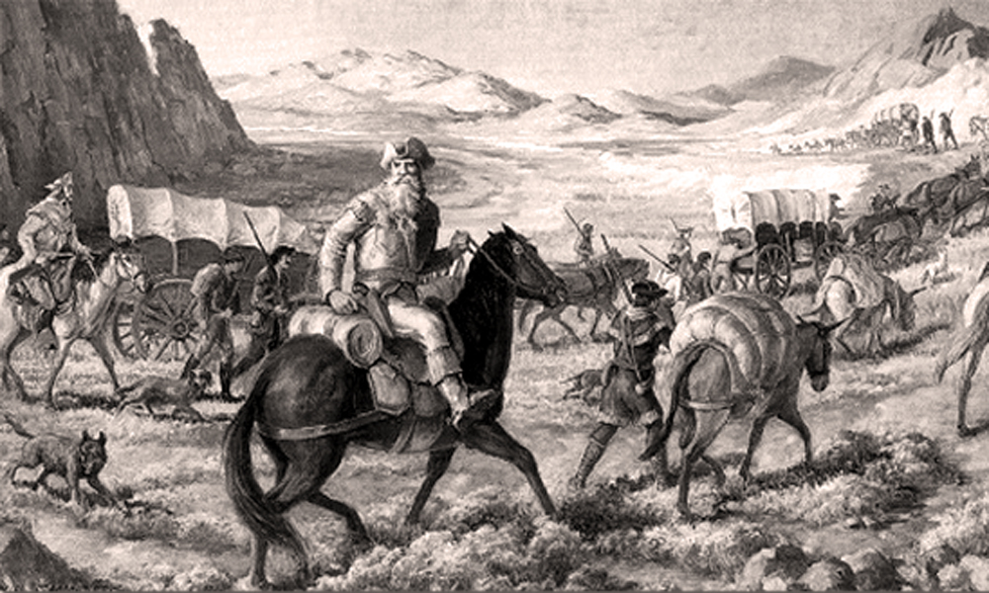

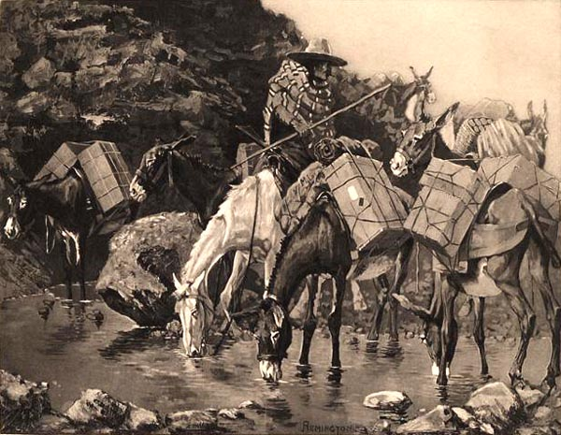

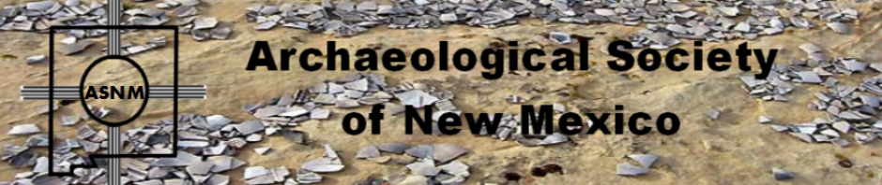

Budget information for 2019-2020 for the Taos Archaeological Society is now posted on the website.

The Taos Archaeological Society is offering Lifetime Membership with the contribution of $500.00 per individual anytime up until December 31, 2019. Take advantage of this Tax Deductible opportunity and help TAS fund our mission!! The Lifetime Membership will include the Member plus 1 additional family member.
TAS
PO Box 143
Taos, NM 87571

The Taos Archaeological Society, in cooperation with Carson National Forest will participate in archaeological testing of a rock shelter site in Valle Vidal Summer of 2020. We will be posting updated information soon to Members.

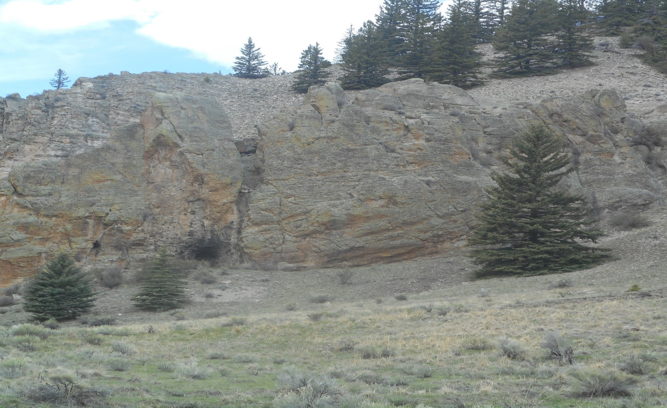

We excavated and surveyed this area for a week August 5-9, 2019 and recorded two hearths and many artifacts. Three new sites were also recorded. We collected lithics including obsidian and 5 ceramics. Also, in the excavation we found an Archaic projectile dart San Pedro variety (see photo below (circa 1500 BC). Great group of archaeology techs and volunteers from TAS.
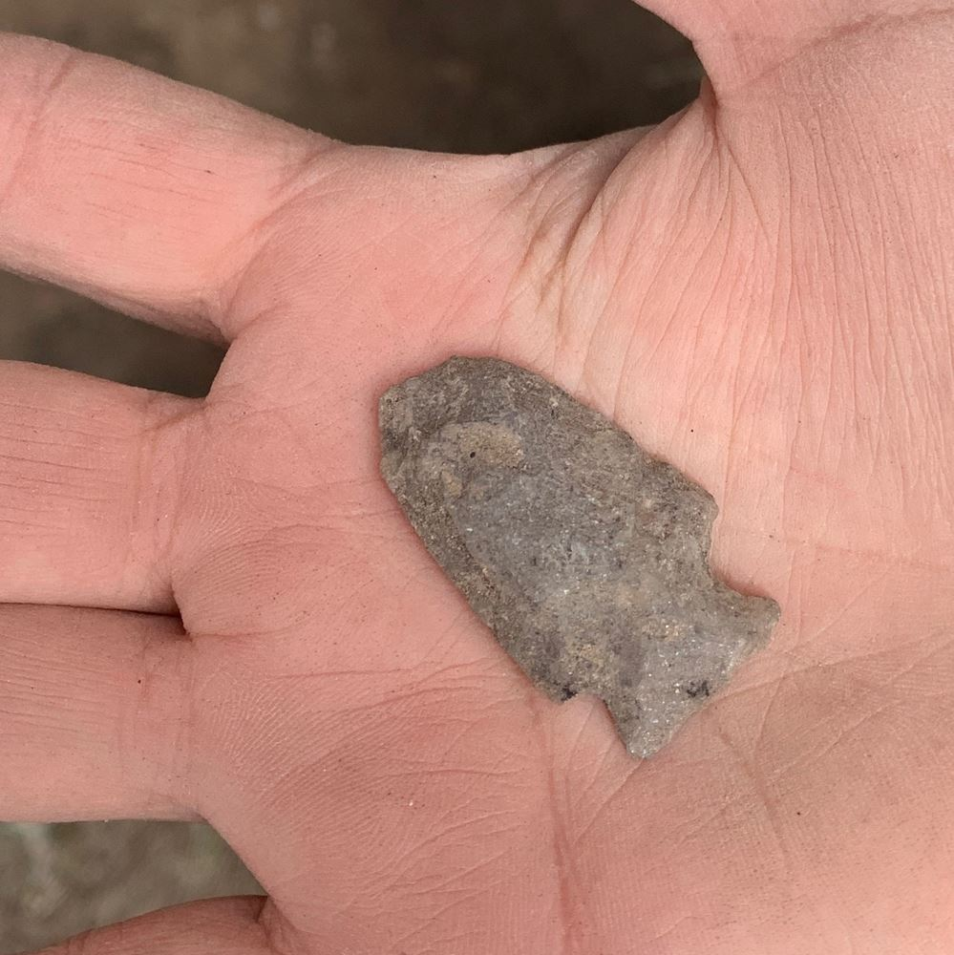
Archaic Dart Armijo Side Notched circa 1500 BC

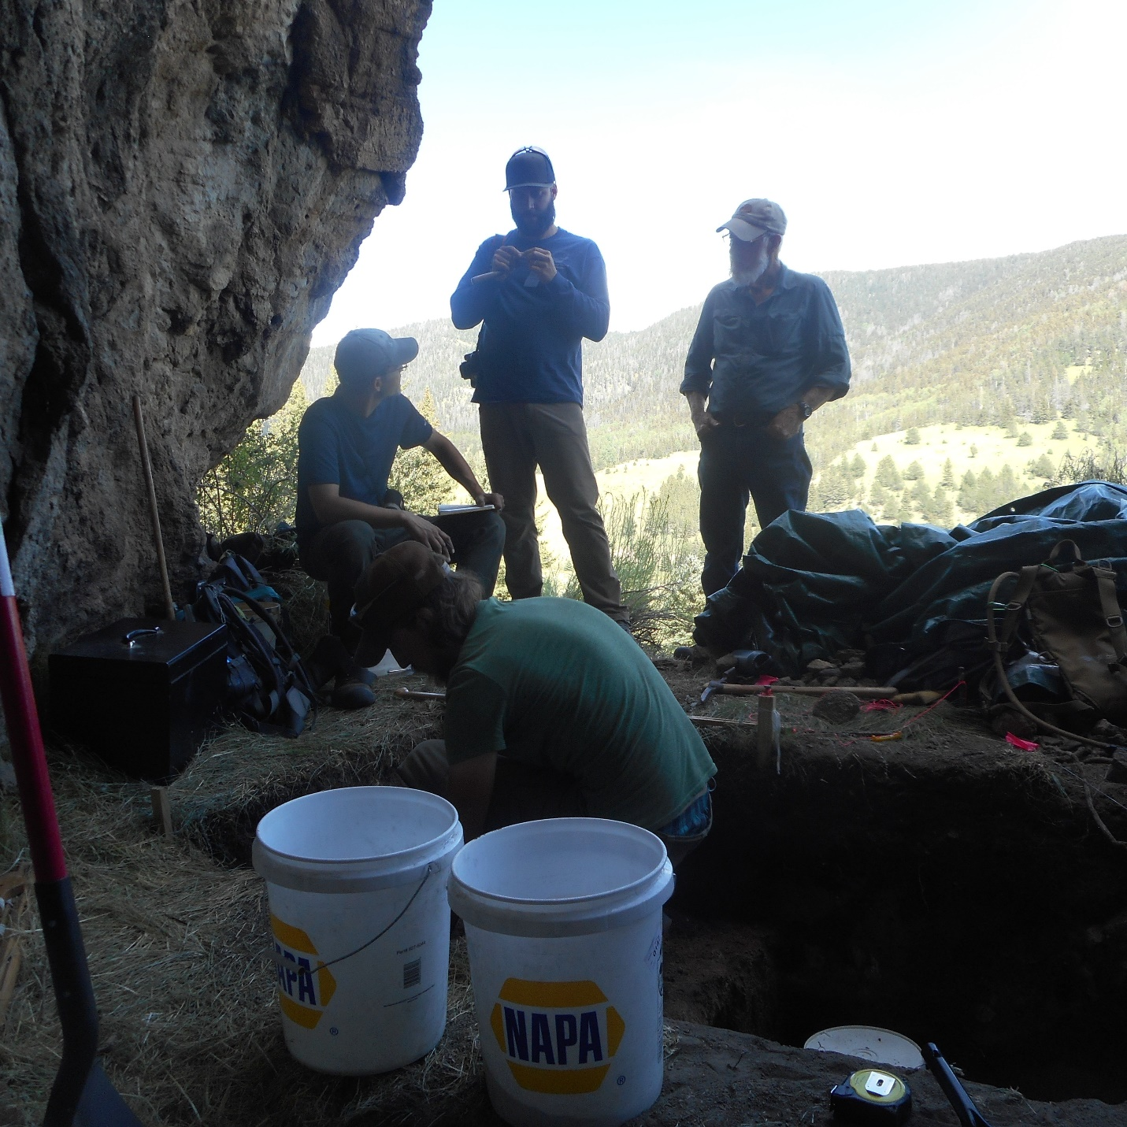

La Cueva excavation underway

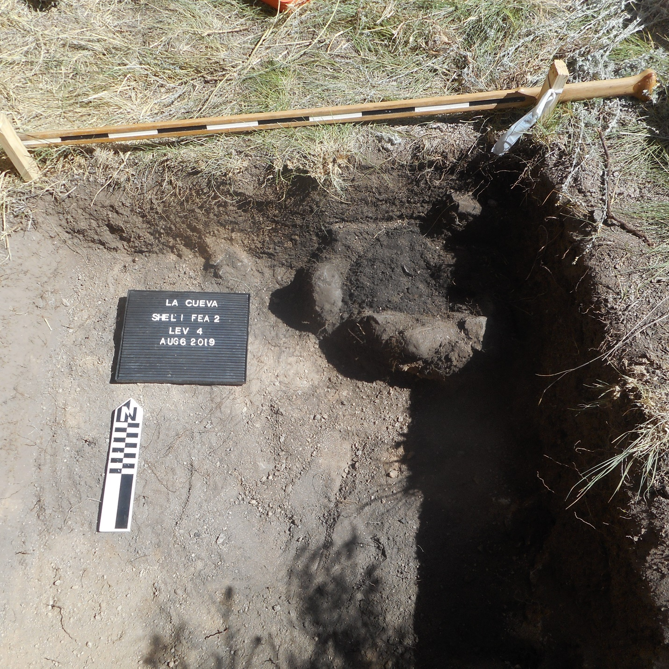

La Cueva Feature 2 Thermal Feature

Winter POT LUCK
COMING SOON!!!
December 7, 2019

St. James Church
Gusdorf Road
500pm-700pm
Bring your favorite Wintertime Dish to Share!!!
Wine and Lemonade provided.

The Taos Archaeological Society is in part Funding trips for students to The Mesa Prieta Petroglyph Project!! Trips coming up this Spring 2020!!!
Contact Phil Alldritt at taoscuba@hotmail.com

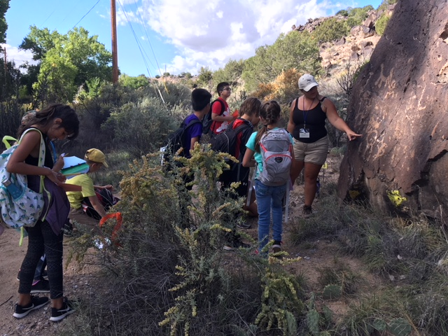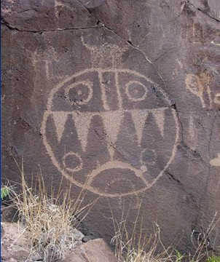

TAS is looking for Members to form an Education Committee who will promote and facilitate communication with teachers and schools to advance our bus trip programs!! To participate in this very successful effort contact Phil Alldritt at taoscuba@hotmail.com
Thank you!!!

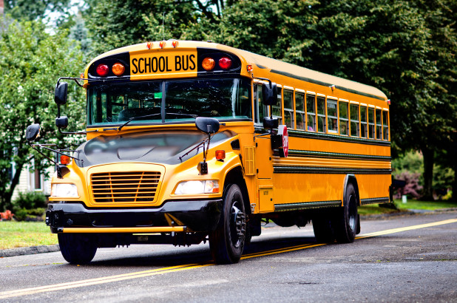

TAS is also looking for Members to participate in organizing TAS archives from 2000-Present. We are requesting that any Members who have photographs from TAS trips and any archival materials to contact Phil Alldritt at taoscuba@hotmail.com. Thank you!!!!!

Upcoming Trips
Trip reservations are first come first serve all trips have limited space. No reservation is confirmed until deposits have been made. Watch for future trips on the website!!!
Thank you!
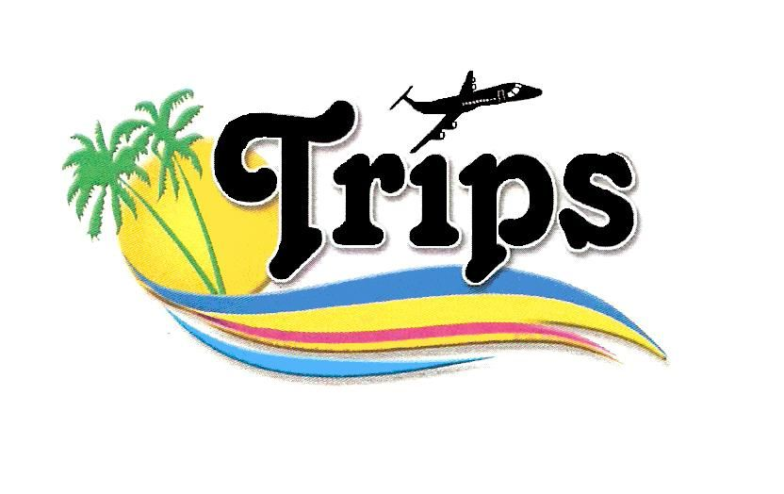All TAS trips may be sign up for by TAS Members who are Active Members in Good Standing. Persons wanting to participate should become Members by mailing 30.00 to
TAS PO Box 143 Taos, NM 87571 Thank you!!
El Morro National Monument
September 17-20, 2019
Guided tour of the petroglyphs and ruins. 3 days.
2 spots remaining!!!! 50.00 participation fee.
Contact Phil Alldritt at taoscuba@hotmail.com

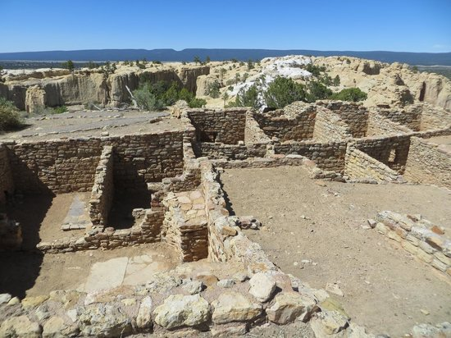
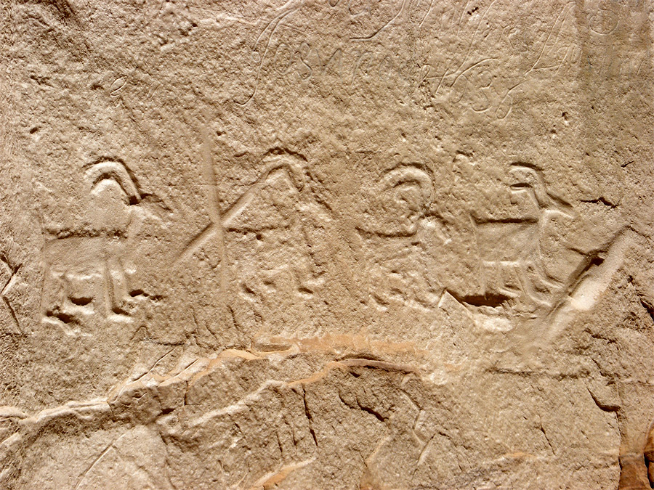

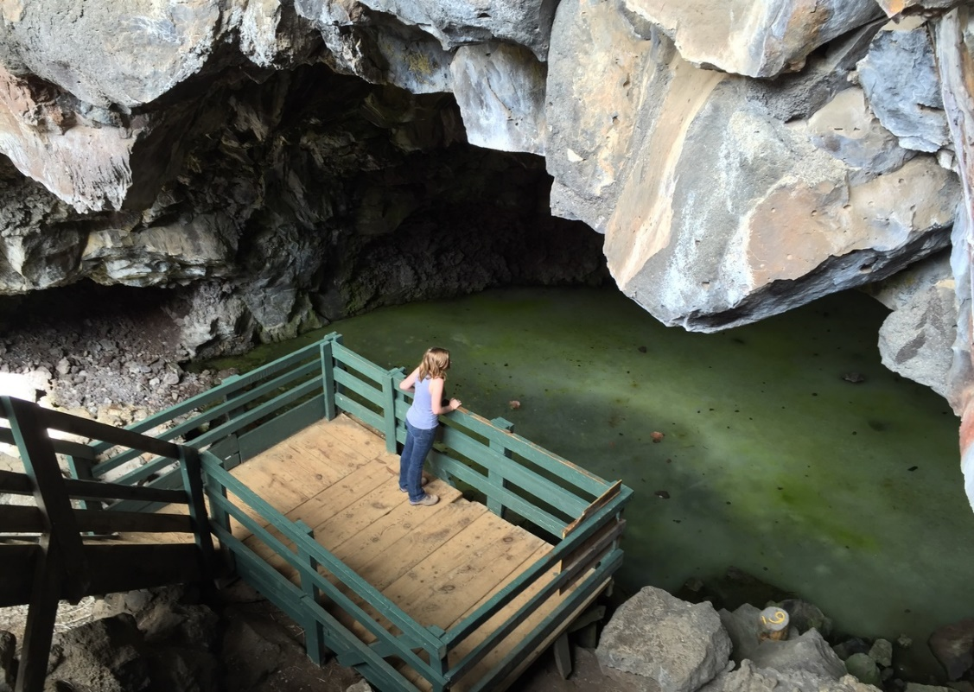
Ice Cave

May 2020
Chaco Canyon 3 Day Trip with Paul Reed
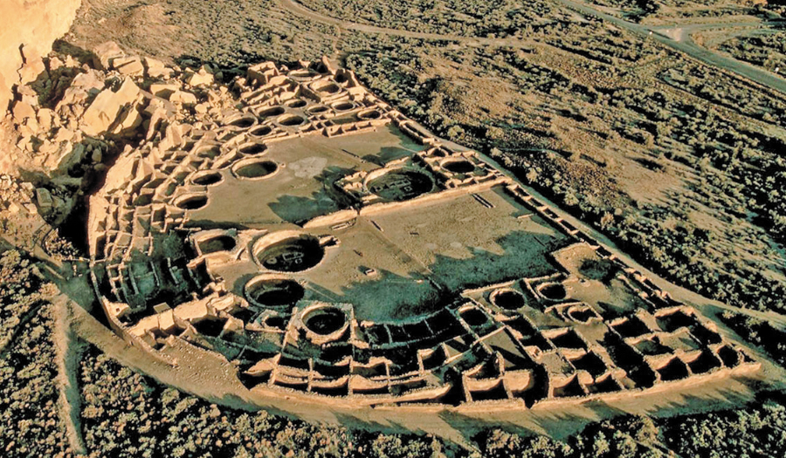
Pueblo Bonito
Next Speaker November 12

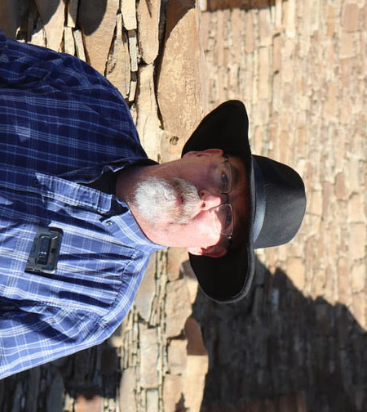

Paul F. Reed
UNM-Taos Professor of Anthropology and Preservation Archaeologist
Paul Reed is a Preservation Archaeologist with the Tucson, Arizona based Archaeology
Southwest and works as a Chaco Scholar at Salmon Ruins, New Mexico. Reed has been
employed in this position for 15 years. Reed has written multiple journal articles and
reports over 30 years as an archaeologist. He completed work as editor (and author of
several chapters) on Chaco's Northern Prodigies: Salmon, Aztec, and the Ascendancy of the
Middle San Juan Region After AD 1100, published by the University of Utah Press in
August 2008. Reed was also editor (and author of several chapters) of the three-volume,
comprehensive report entitled Thirty-Five Years of Archaeological Research at Salmon
Ruins, New Mexico published in 2006 by the Center and the Salmon Ruins Museum. His
other books -- The Puebloan Society of Chaco Canyon and Foundations of Anasazi Culture
(as editor) have explored the origins of ancient Pueblo culture and Chaco Canyon.
For the last two years, Reed has been working to protect the Greater Chaco Landscape from the
effects of expanded oil-gas development associated with fracking in the Mancos Shale
formation. Through a series of meetings and forums with public officials, Tribal leaders, various
US Government agencies, and New Mexico’s Congressional delegation, Archaeology Southwest
and its partners have focused on expanding protections to sites, traditional cultural places, and
fragile landscapes in the greater San Juan Basin.

Topic

Aztec, Salmon, and the Middle San Juan as a Pueblo Heartland

Paul F. Reed

The Middle San Juan region of northwestern New Mexico is often misunderstood regarding its Puebloan history. Falling between the better-known Pueblo cultural centers at Chaco Canyon and Mesa Verde, the ancient Aztec and Salmon communities rarely attract deserved attention. Research at these Puebloan centers over the last 100, and particularly, the last 20 years has revealed a unique and outstanding record of innovation and creativity, as well as large numbers of Pueblo-affiliated peoples. In this talk, I will highlight the special nature of the ancient Puebloan use of the Middle San Juan region. I will also provide a brief update on our efforts to protect the Greater Chaco Landscape from oil-gas development

.

