The Taos Archaeological Society
September 14, 2021
5:30pm (Sign in by 5:25pm) Zoom ID 545 842 9500

Tonight’s Speaker
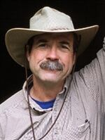
Tradition, and Sheepscapes
Andrew Gulliford
2021
From his book The Woolly West: Colorado’s Hidden History of Sheepscapes, Dr. Andrew Gulliford will speak about poor Hispanic sheepherders pastores, and wealthy Hispanic sheep owning families or ricos who transformed the West by the grazing of thousands of sheep across New Mexico and Colorado. He will discuss the history of sheep grazing as well as describe a powerful love story between Aldo Leopold and Estella Luna Otero Bergere. Gulliford will discuss the brutal sheep and cattle wars and explain historical archaeology and the wide variety of sites related to sheep movements, sheep camps, cairns, aspen tree carvings, and lonely sheepherder lifeways in Colorado’s high country for summer grazing. He will show photographs, and discuss cultural traditions and stories of Hispano herders who have grazed and still graze U.S. National Forest and BLM lands. Questions and stories from the audience will be welcomed.
Gulliford received the National Individual Volunteer Award from the U.S. Forest Service. The Woolly West won the Colorado Book Award for History and the Wrangler Western Heritage Award for Outstanding Non-Fiction from the National Cowboy Museum & Heritage Center. Dr. Gulliford is a professor of history at Fort Lewis College in Durango.
Andrew Gulliford is a professor of history and Environmental Studies at Fort Lewis College in Durango, Colorado. He teaches popular courses on wilderness, national parks, Western history, and environmental history. He is the author of America’s Country Schools, Sacred Objects and Sacred Places: Preserving Tribal Traditions, and Boomtown Blues: Colorado Oil Shale, which won the Colorado Book Award. He edited Preserving Western History, which was voted one of the best books on the Southwest by the Tucson-Pima County Library. His book Outdoors in the Southwest: An Adventure Anthology won the Arizona/New Mexico Book Award in the category of nature/environment and Best Book on Arizona. Outdoors in the Southwest also won the Colorado Book Award for best anthology.
Gulliford has had led tours across the West by canoe, raft, horseback, van, cruise ship, private train, and private jet for the Smithsonian Institution, National Geographic Society, the National Trust for Historic Preservation, Rocky Mountain Public Broadcasting Service (PBS), Great Old Broads for Wilderness, History Colorado, Canyon Country Discovery Center, and the San Juan Mountains Association.
Dr. Gulliford has received the National Individual Volunteer Award from the U.S. Forest Service for wilderness education, and a certificate of recognition from the Secretary of Agriculture for “outstanding contributions to America’s natural and cultural resources.” For a decade he held a federal appointment to the Southwest Colorado Resources Advisory Council of the Bureau of Land Management. He also served on Colorado’s State Review Board for the state and historical registers of historic places. In 2016 he was one of two senior fellows awarded the Aldo and Estella Leopold Residency at Tres Piedras, New Mexico to research and write in the bungalow Aldo built for his wife in 1912 on the Carson National Forest.
Gulliford edited The Last Stand of the Pack: A Critical Edition, published by the University Press of Colorado. He writes columns about the Southwest for the Durango Herald, the Cortez Journal, and the San Juan Record (Monticello, Utah) and he appears in history programs for “The Colorado Experience” television series produced by Rocky Mountain PBS. He has appeared in films about The Cattle and Sheep Wars; The Press of the West; Senator Ben Nighthorse Campbell; and The Strater Hotel.
His book The Woolly West: Colorado’s Hidden History of Sheepscapes (Texas A&M University Press, 2018) was chosen the Outstanding Nonfiction winner for the 2019 Western Heritage Awards sponsored by the National Cowboy & Western Heritage Museum in Oklahoma City. The Woolly West also won the Colorado Book Award in 2019.
Message for the Members of TAS:

Hope you had a great summer and all getting vaccinations so we can begin to have face to face meetings as soon as possible. As of now, we will continue to have Zoom lectures until January 2022.

We are mostly restricted as the Kit Carson is not allowing any groups to meet in person yet. We will keep you updated when that changes. This, of course, is their decision.

Please go to You Tube and Enter Taos Archaeological Society for recorded Lectures you may have missed.

Until then, stay healthy and safe,

Thank you and we will see you all soon.

The TAS Officers

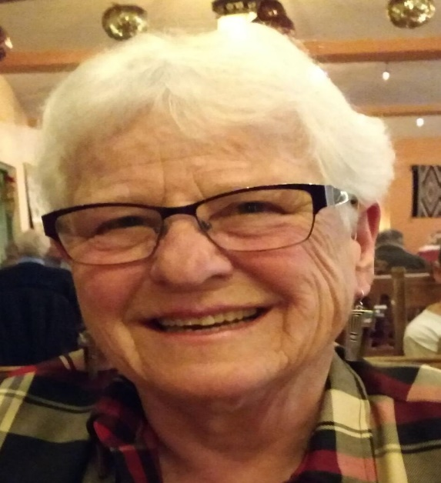

To the Membership of the Taos Archaeological Society,

I am pleased to announce the creation of a charitable fund we received from the estate of Carolyn Johnson (CJ). TAS received a donation of 15,000.00 from CJ to continue our mission that began back in 1987. The fund will dispense a growth check to TAS each February that amounts to an estimated 4-5% of the endowment each year (approximately 700.00). This will be deposited into the TAS General fund to be used for the support of our various educational and scientific goals.
While the principal of 15,000.00 never changes, it can grow by members donating to the fund. The Taos Community Foundation supports many groups in Taos and Colfax Counties. Your donations can be made by visiting Taos Community Foundation online and going to the Non-profits area to find TAS.
TCF is a non-profit 501 c3 and your donations are tax deductible. This fund is highly regulated and is currently secured by $20,000,000 supporting many Taos County and Colfax County organizations.
We thank CJ for this gift that will keep on giving for years to come and ensure the security and support of the Taos Archaeological Society.

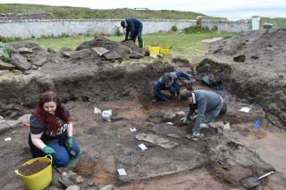

An effort is currently underway to build a historical timeline of events in the history of the Taos Archaeological Society. We need your help if you have records that date in the period September 1999 through February 2014. These dates range between the last completed history for the society and the earliest records archived on our web site.

The Taos Archaeological Society has operated for 34 years. At present documents we have accessible cover under 60 percent of that time. Old bulletins, meeting minutes, financial statements, member lists and other communications of the society will assist in this effort. Please do help if you can. You can send records directly to Paul McGuff (pmcguff@aol.com).

TAS, SMU-Taos and the Picuris Pueblo in Partnership!!!

A New Ceramic Analysis Committee Has been formed!!

Ceramic Sorting and Analysis is getting organized for a pilot project to have analysis conducted on a private take home individual basis to observe Covid-19.

Picuris Analysis Ceramic Sorting is still requesting volunteers to participate in processing out their Prehistoric collections. Contact Mark Henderson for more information. markscotthenderson@gmail.com

Join the Sherders Zoom meetings each Wednesday at 9am to get updated on the activities going forward.

Zoom Id Number Meeting ID: 878 3989 2686

Taos Black on White
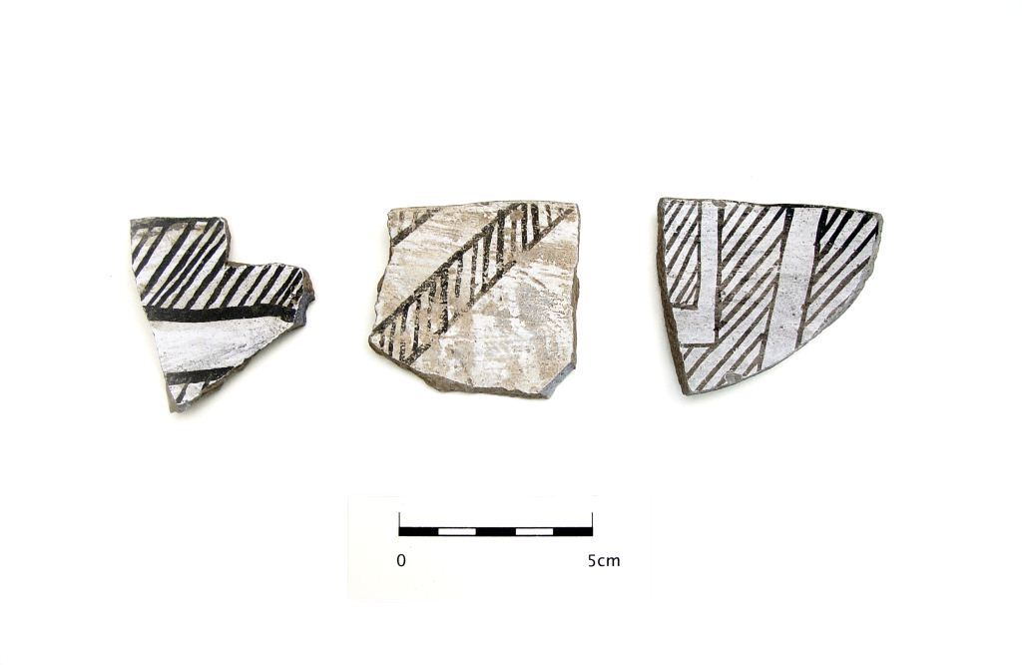
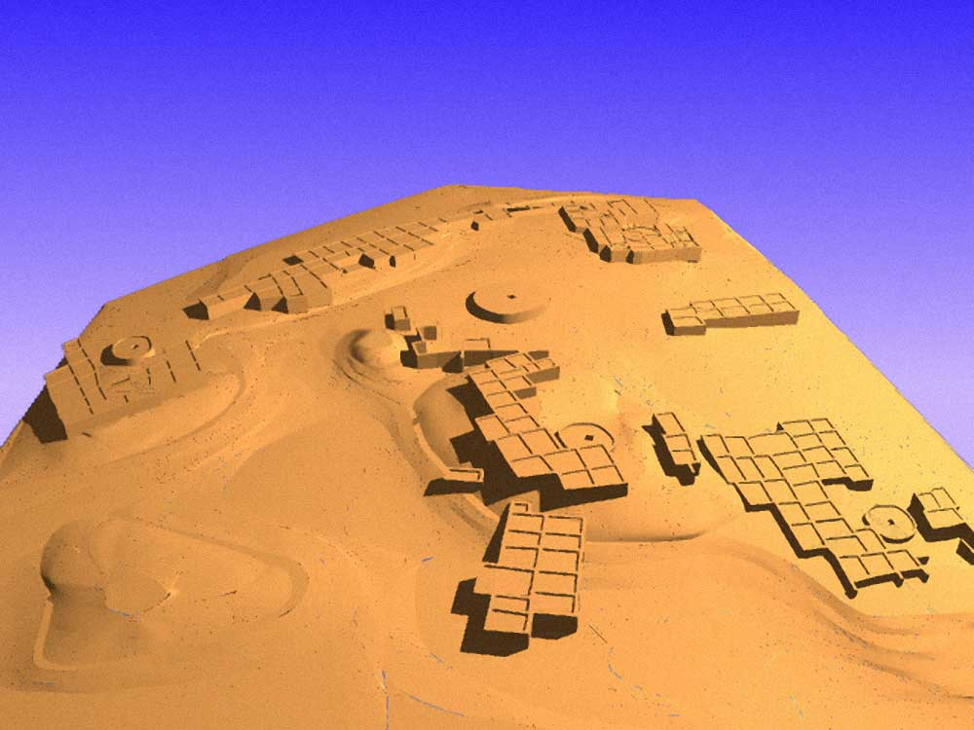

Pot Creek Pueblo 1320 AD

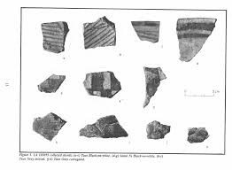
Slate of TAS Officer Elected for 2021-2022
February 1, 2021 until January 31, 2022

Phil Alldritt President
Cassandra Keyes Vice President
Debbie Espie Secretary
Chris Ellis Treasurer
Anita Briscoe At Large

Webmaster (Non Officer position)
Phil Alldritt

The Current Committee Chairs Are as follows:

Education Committee Anita Briscoe

Fieldwork Committee Gary Grief

Newman Dome Subcommittee Cassandra Keyes

Picuris Ceramic Analysis Committee Mark Henderson

Blumenshein Ceramic Analysis Committee For Charter Development
Kurt Weidler/ Jeff Boyer/Becky Quintana/Paul McGuff

Program Committee Cassandra Keyes, Debbie Dean, Phil Alldritt

Trip Committee Paul Reed , Phil Alldritt

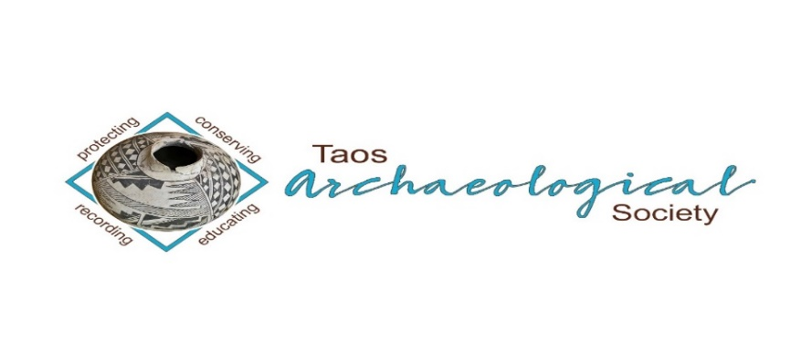
The Taos Archaeological Society is pleased to announce we are hosting the Annual Meeting of ASNM. The Conference will take place May 6-8, 2022 next Spring. TAS is looking for volunteers to participate in helping Saturday May 7. The Meeting theme will be “Taos at the Crossroads of Trade”.

Register on the TAS website coming soon at taosarch.org

Interesting lectures, Field Trips, Steve Lekson keynote speaker and Banquet Dinner. Burro loading demonstration,
Silent Auction.

Contact Phil Alldritt at taoscuba@hotmail.com to participate as a volunteer.
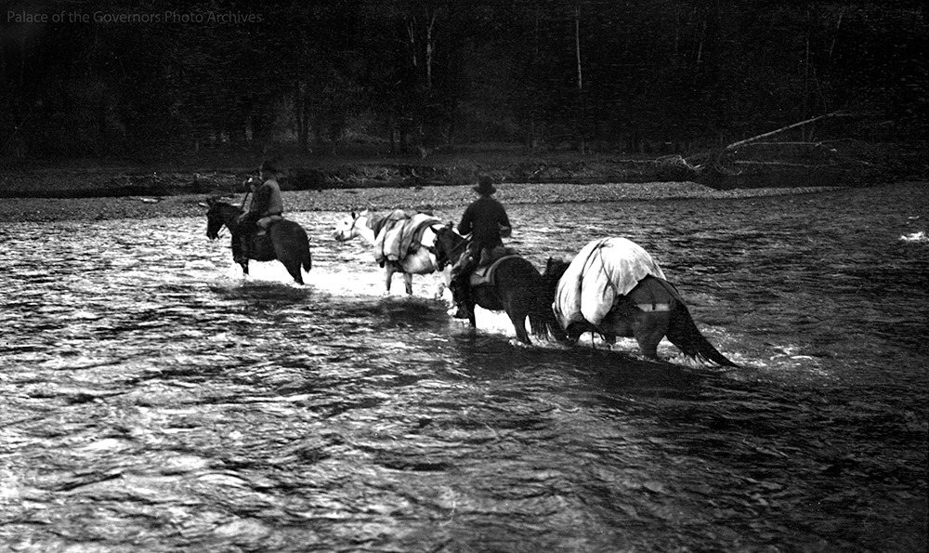

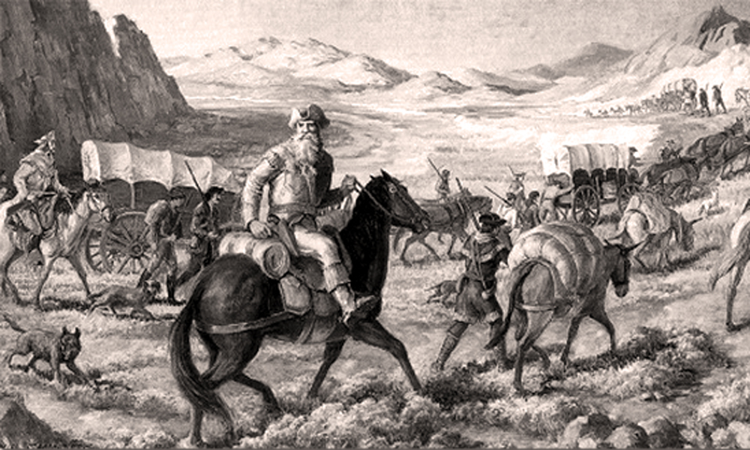

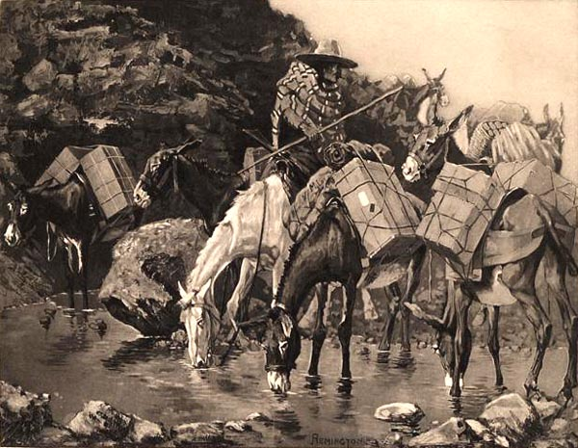

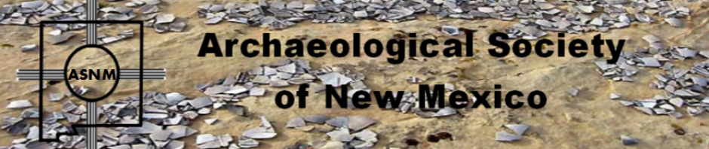

Budget information for 2021 for the Taos Archaeological Society is now posted on the website.

2022 Membership Dues can be paid now!!!!

The Taos Archaeological Society is offering Lifetime Membership with the contribution of $500.00 per individual anytime up until December 31, 2021. Take advantage of this Tax Deductible opportunity and help TAS fund our mission!! The Lifetime Membership will include the Member plus 1 additional family member.
TAS
PO Box 143
Taos, NM 87571

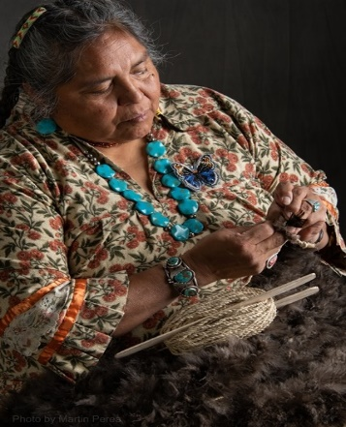
THIS ACTIVITY Has Been Rescheduled for Saturday JUNE 11, 2022
Members already paid are signed up!!!

To the Membership of the Taos Archaeological Society,

On Saturday, June 11 ,2022, Mary Motah will conduct a basket and sandal weaving demonstration and hands on workshop for TAS members. The workshop will take place at the Kit Carson Board Room on Cruz Alta Road from 10am-4pm.

The participation is limited to 15 persons. This will fill quickly. Registration based on first 15 payments received. Please include your email to receive a confirmation.

If you miss out we will do this in an ongoing basis. The second 15 payments received will be confirmed to participate in the June 2023 workshop.

The participation fee is $15.00 check or money order made out to Mary Motah. It should be mailed to

Phil Alldritt
PO Box 659
Arroyo Hondo, NM 87513

First 15 deposits received are confirmed. No one is confirmed until payment is received.

Participants should bring a small pocket knife, wear shorts, bring brownbag lunch and drink.

In case of cancellation and you request a refund contact me here.

Thank you for your support and participation in the TAS activities!!

STAND BY FOR UPDATES FOR
SUMMER POT LUCK

TAKING RESERVATIONS FOR SPRING 2022!!!!!
The Taos Archaeological Society is Funding trips for students to The Mesa Prieta Petroglyph Project!! Trips coming up in Spring 2022!!! COVID PERMITTING!!!
Contact Phil Alldritt at taoscuba@hotmail.com

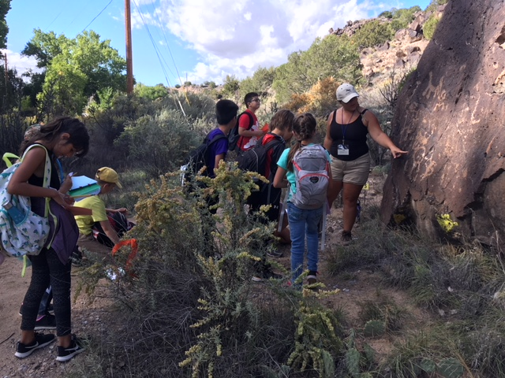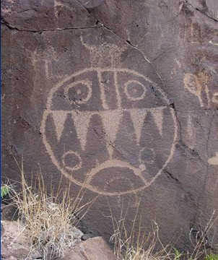

TAS is looking for Members to form an Education Committee who will promote and facilitate communication with teachers and schools to advance our bus trip programs!! To participate in this very successful effort contact Phil Alldritt at taoscuba@hotmail.com
Thank you!!!

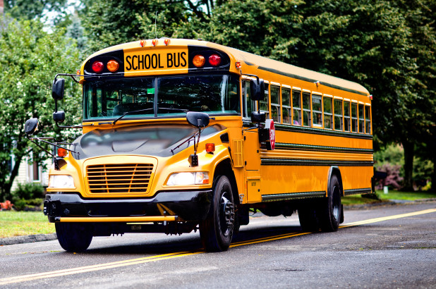

Upcoming Trips
Trip reservations are first come first serve all trips have limited space. No reservation is confirmed until deposits have been made. Watch for future trips on the website!!!
Thank you! COVID PERMITTING!!!
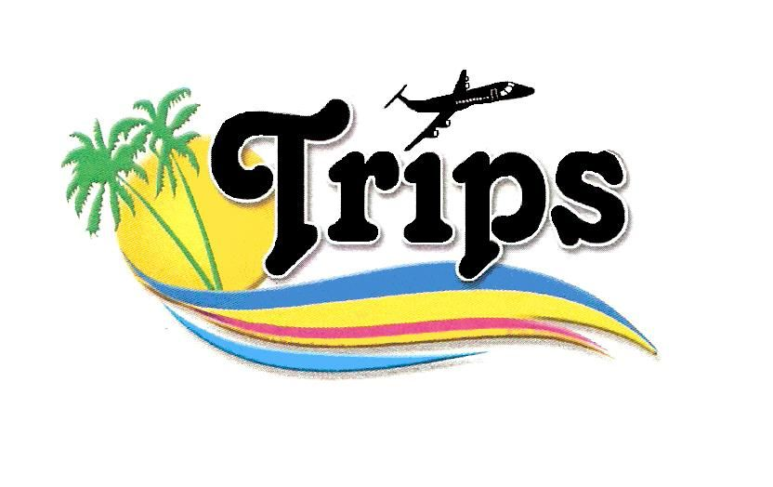All TAS trips may be sign up for by TAS Members who are Active Members in Good Standing. Persons wanting to participate should become Members by mailing 30.00 to
TAS PO Box 143 Taos, NM 87571 Thank you!!!

Next Speaker
October 12, 2021

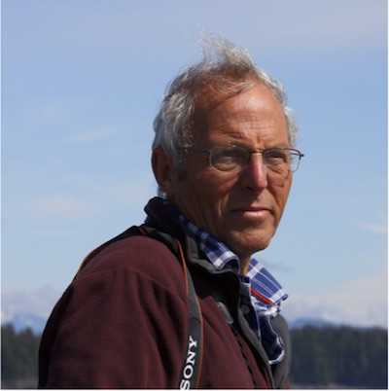
Christopher Caseldine
Tonto Basin: An Outpost, Boundary, Cultural Crossroads, or Something Else in Central Arizona
The Tonto Basin in central Arizona was central to the archaeological development of the Hohokam and debates that raged around Salado. Work sponsored by the Bureau of Reclamation and the Arizona Department of Transportation in the 1980s and 1990s pushed the study of Tonto Basin archaeology lightyears ahead, but what came before and after Salado remains understudied. In this talk, I present an overview of the Tonto Basin development history and research questions yet to be answered. I will briefly discuss projects I am initiating on Tonto National Monument and Tonto National Forest that could inform on ancient travel routes between the northern and southern Southwest, and changes in settlement and agriculture patterns in the Tonto Basin.
Christopher (Chris) Caseldine is the Anthropological Research Collection Manager in the Center for Archaeology and Society Repository, School of Human Evolution & Social Change at Arizona State University. His research has focused on reconstructing ancient irrigation systems in the lower Salt River Valley (Phoenix Basin, Arizona) to provide insight into the relationship between water availability and sociopolitical change among the Hohokam. Chris has expanded his research to the Tonto Basin and neighboring areas below the Mogollon Rim, and is interested in Hohokam identity and the transition period between Hohokam and Salado.

Exciting speakers coming all next year 2021and 2022!!!! Watch for the bulletins beginning again in September online at taosarch.org for announcements!!!!

.

.

