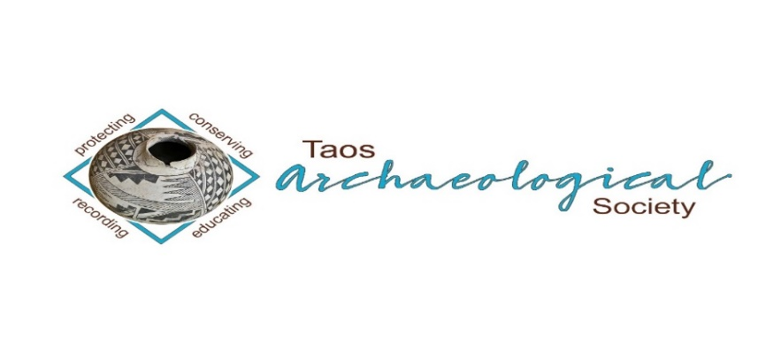

The Taos Archaeological Society

BULLETIN February 2023

Next Speaker
MONDAY February 6, 2023
LIVE AT THE KIT CARSON BOARD ROOM AT 7pm

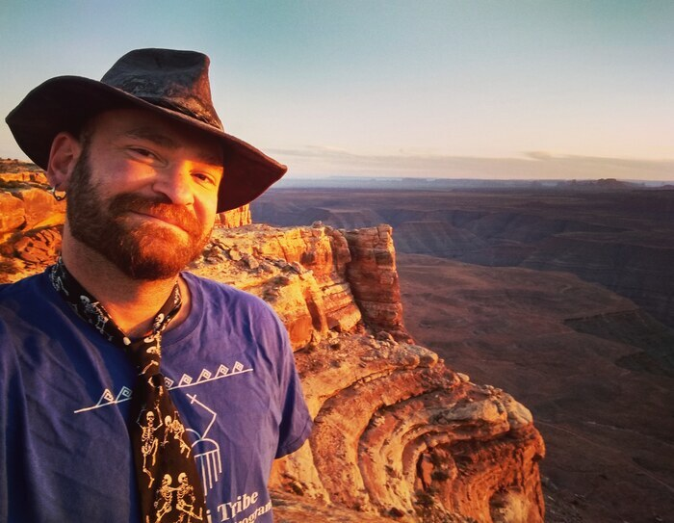
Ralph Burrillo
Bears Ears
Ralph "R.E." Burrillo is an archaeologist, author, and conservation advocate with degrees from Northern Arizona University and the University of Utah. His writing has appeared in Archaeology Southwest, Colorado Plateau Advocate, The Salt Lake Tribune, Blue Mountain Shadows, The Moab Times, The Navajo-Hopi Observer, Kiva, The Gulch, The Dust, The Archaeological Record, Flag Live, The San Juan Record, and Southwestern Lore. He is also the author of Behind the Bears Ears: Exploring the Cultural and Natural Histories of a Sacred Landscape, which was chosen by ForeWord Book Reviews as their critic's choice in nonfiction for the year 2020; and the more recent The Backwoods of Everywhere: Words from a Wandering Local. He currently splits his time between Scottsdale and Flagstaff, AZ.

TOPIC
About the talk: "The Battle for Bears Ears: 120 Years of Conservation History." Southeastern Utah has one of richest and most diverse sagas of human history, dating back at least 12,000 years. Since its popularization starting in the 1870s, the rich material heritage of the place has faced steady threats from development, grazing, looting, and - increasingly - recreational visitation. Efforts to implement legislative protection have existed for almost as long, but have always lagged far behind the pace of the impacts they are meant to curtail. Now they are on a collision course whose fate is yet to be determined.
PLANNED TRIPS FOR 2023
May 2023 Chaco Canyon Trip (Dates TBD)
June 2-3, 2023 Folsom Site Space Available (8)
October 2023 Bears Ears (Dates TBD)
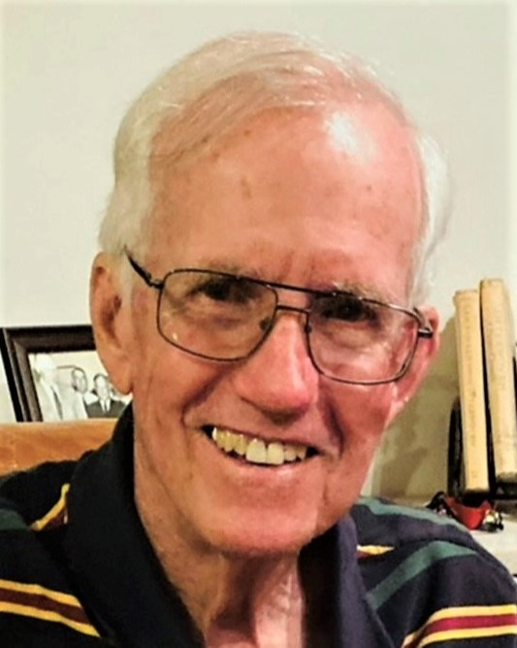

Taos Archaeological Society is sad to announce the passing of Don Keefe on Thursday 12/29. His notice written by Charlotte, with the obituary link, is below. Life Celebration is scheduled for January 6. Don was past president of TAS, and was a great friend and supporter. He will be missed.
Don Keefe passed away Thursday, December 29. A Celebration of Life gathering will be Friday, Jan. 6 at 10:30 am. at De Vargas funeral home.
You can read his obituary online. devargastaos.com
The service will be live streamed. Here is the link
https://event.forgetmenotceremonies.com/ceremony?c=fe464019-8b04-4897-a0d1-aaf3ac9fd3b6
In lieu of flowers a donation can be sent to the Taos library for the purchase of books for children and youth. Address: Friends of the Taos Library, 402 Camino de la Placita, Taos, NM 87571.

In memory of Don, TAS will be making a donation to the Taos Library on behalf of the TAS Membership.

WELCOME BACK TO IN PERSON LECTURES. WE MEET AT THE KIT CARSON ELECTRIC COOP ON CRUZ ALTA at 7pm.
PLEASE BE VACCINATED AND BOOSTED FOR THE HEALTH AND SAFETY OF THE GROUP. Feel free to wear a mask according to your comfort level. We recommend this to stay safe from all air born transmission.
The TAS Monthly Lectures are recorded (unless the speaker requests we not record it) and will be available on You Tube three days after the live meeting.
Please watch your emails as we may move meetings to ZOOM only as Health protocols change or weather becomes an issue. Thank you.

ELECTION OF NEW OFFICERS FOR 2023-2024
The NEW Officers for TAS 2023-2024 have are now being confirmed or rejected by electronic vote of the TAS Membership.
Vote Yes or No at tasorg@hotmail.com until 12:00 Midnight on January 31, 2023. Thank you!!
Philip Alldritt
Cassandra Keyes
Debbie Espie
Chris Ellis

Message for the Members of TAS:

Hope you had Happy Holidays and are all getting vaccinations and boosters so we can ensure the health and safety of those who attend in person lectures.
We begin again with LIVE LECTURES MONDAY February 6, 2023. In person lectures will be at the Kit Carson Electric Coop Board Room. 7pm -830pm as usual.
Please go to You Tube and Enter Taos Archaeological Society for recorded Lectures you may have missed.

The lectures from ASNM this Spring 2022 are recorded on You Tube.
Search: Archaeological Society of New Mexico Annual Meeting 2022 DAY One, DAY TWO, or DAY THREE.

Until then, stay healthy and safe,

Thank you and we will see you all soon.

The TAS Officers

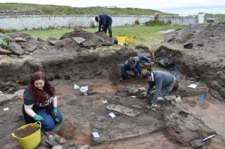

An effort is currently underway to build a historical timeline of events in the history of the Taos Archaeological Society. We need your help if you have records that date in the period September 1999 through February 2014. These dates range between the last completed history for the society and the earliest records archived on our web site.

The Taos Archaeological Society has operated for 35 years. At present documents we have accessible cover under 60 percent of that time. Old bulletins, meeting minutes, financial statements, member lists and other communications of the society will assist in this effort. Please do help if you can. You can send records directly to Paul McGuff (pmcguff@aol.com).

TAS, SMU-Taos and the Picuris Pueblo in Partnership!!!

An update to the Ceramic Analysis Projects is coming soon in Spring 2023.

Ceramic Sorting and Analysis is getting organized for a pilot project to have analysis conducted on a private take home individual basis to observe Covid-19.

Picuris Analysis Ceramic Sorting is still requesting volunteers to participate in processing out their Prehistoric collections. Contact Mark Henderson for more information. markscotthenderson@gmail.com

Sherder’s ZOOM MEETINGS temporarily suspended.

Zoom Id Number Meeting ID: 878 3989 2686

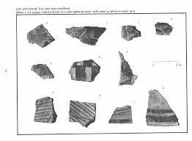

Taos Black on White
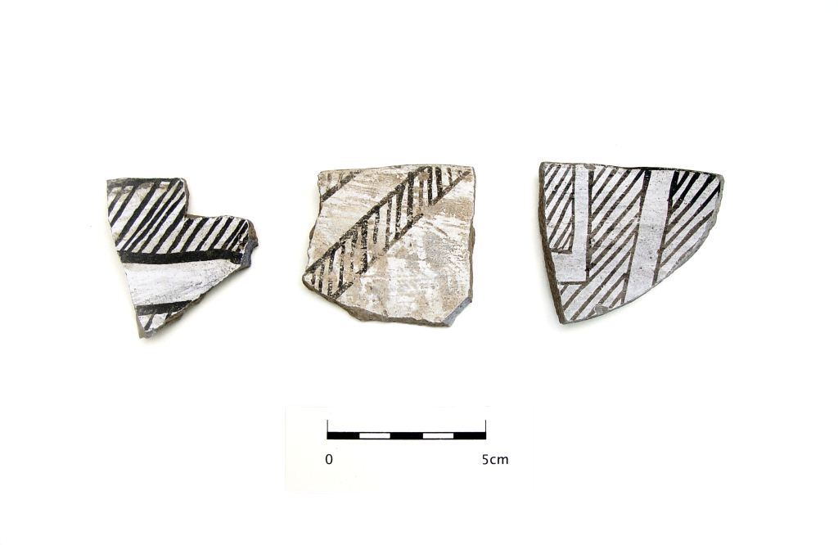
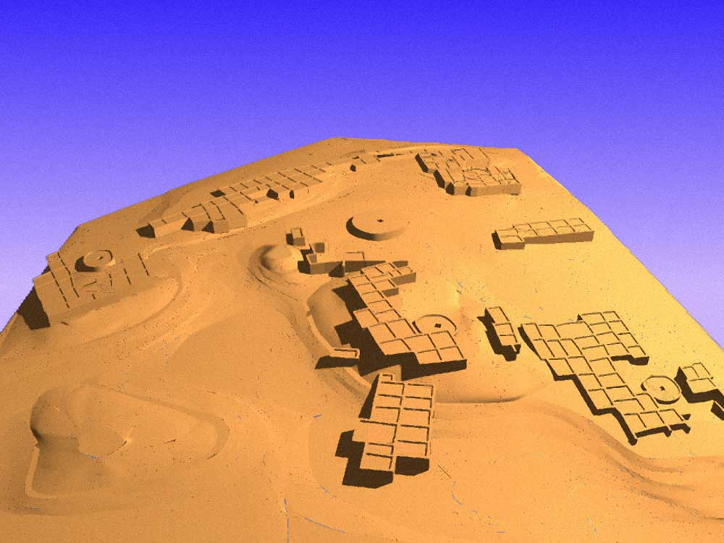

Pot Creek Pueblo 1320 AD

Slate of TAS Officer Elected for 2022-2023
February 1, 2022 until January 31, 2023

Phil Alldritt President
Cassandra Keyes Vice President
Debbie Espie Secretary
Chris Ellis Treasurer

Webmaster (Non Officer position)
Phil Alldritt

The Current Committee Chairs Are as follows:

Education Committee Anita Briscoe/Phil Alldritt

Fieldwork Committee Gary Grief

Scholarship Subcommittee Cassandra Keyes

Picuris Ceramic Analysis Committee Mark Henderson

Blumenshein Ceramic Analysis Committee For Charter Development
Kurt Weidler/ Jeff Boyer/Becky Quintana/Paul McGuff

Program Committee Cassandra Keyes, Debbie Dean, Phil Alldritt

Trip Committee Paul Reed , Phil Alldritt

Lifetime memberships are possible anytime for TAS. For $500.00 you will receive Lifetime membership plus 1. This can be a spouse or partner. Contact tasorg@hotmail.com if interested. Thank you!
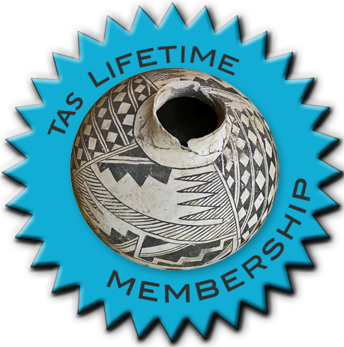

TAKING RESERVATIONS FOR
SPRING 2023!!!!!
The Taos Archaeological Society is Funding trips for students to The Mesa Prieta Petroglyph Project!! Trips coming up in Spring 2023!!!
Contact Phil Alldritt at taoscuba@hotmail.com

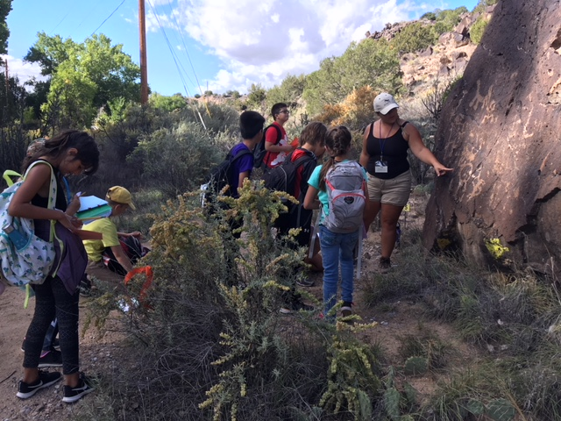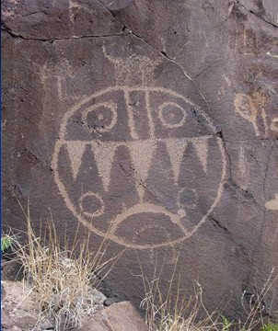

TAS is looking for Members to form an Education Committee who will promote and facilitate communication with teachers and schools to advance our bus trip programs!! To participate in this very successful effort contact Phil Alldritt at taoscuba@hotmail.com
Thank you!!!

Upcoming Trips
Trip reservations are first come first serve all trips have limited space. No reservation is confirmed until deposits have been made or Membership confirmed. Watch for future trips on the website!!!
Thank you!
PLANNED TRIPS FOR 2023
May 2023 Chaco Canyon Trip (Dates TBD)
June 2-3, 2023 Folsom Site Space Available (8)
October 2023 Bears Ears (Dates TBD)

All TAS trips may be sign up for by TAS Members who are Active Members in TAS. Persons wanting to participate should become Members by mailing 30.00 to
TAS
PO Box 143
Taos, NM 87571 Thank you

NEXT SPEAKER
Joeseph Birkmann
MONDAY MARCH 6, 2023
Kit Carson Board Room at 7pm.
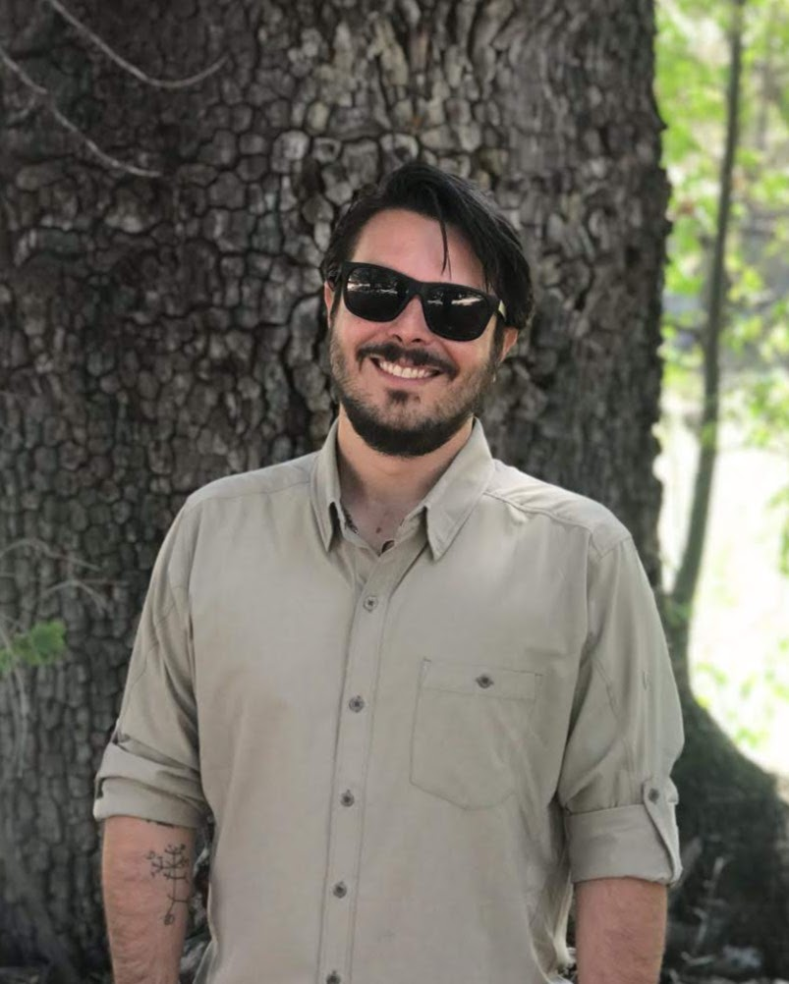
Joseph Birkmann is a Ph.D candidate and archaeologist at the University of New Mexico focused on the Archaic period archaeology of New Mexico and Arizona. He is a lithicist and geoarchaeologist whose research examines projectile point typology during the Archaic period and the transition to agriculture during the late-Middle Archaic in the Southern Southwest.
Topic
The Early Agricultural Period in the Fishhooks Wilderness Area, Safford, AZ
Despite an early emphasis on rockshelters in the history of Early Agricultural Period (EAP) research in the Southwest, a tremendous shift in focus towards the large pithouse villages located on the floodplains of rivers like the Santa Cruz (AZ) has occurred over the past 30 years. Here I provide new data regarding the EAP occupation of the Fishhooks Wilderness Area, a rugged volcanic landscape over 1000 feet above the floodplain of the Gila River, and the location of McEuen Cave, a well-known EAP site with evidence for both maize and squash cultivation at ca. 4100 cal BP. In particular, I discuss the recent research at two rockshelter sites within the wilderness, AZ W:13:1 and AZ W:13:29, including new chronometric data on domesticates from these shelters, and a comparison of these occupations with the floodplain sites that currently dominate the record.

Exciting speakers coming all this year in 2023!!!! Watch for the bulletins beginning each month online at taosarch.org for announcements!!!!

.

.

