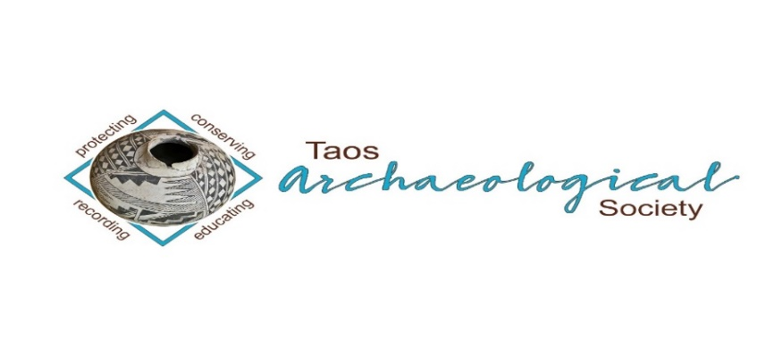
The Taos Archaeological Society

BULLETIN OCTOBER 2022

WELCOME BACK TO IN PERSON LECTURES. WE MEET AT THE KIT CARSON ECTRIC COOP ON CRUZ ALTA at 7pm.
PLEASE BE VACCINATED AND BOOSTED FOR THE HEALTH AND SAFETY OF THE GROUP. Feel free to wear a mask according to your comfort level. We recommend this to stay safe from all air born transmission.
Zoom Meetings are suspended until health and safety protocols require us to return to online lectures

Next Speaker October 3, 2022
Michael Burney
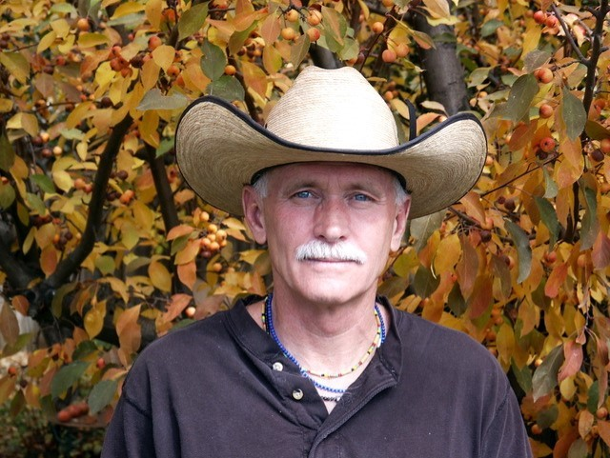

My career as an applied archaeologist began in 1975, while residing in Boulder, Colorado. Before relocating to Taos in 1997, I participated in numerous archaeological projects throughout the western United States. Unfortunately, not one of these projects had the benefit of Native participation. That is, until 1987, when I was hired in Denver, by the Council of Energy Resource Tribes (CERT) to establish a tribal archaeological contracting program for the Confederated Tribes of the Umatilla Indian Reservation (CTUIR) in Pendleton, Oregon. Finally, after 12 years as a contracting archaeologist, I had the unique, and long overdue, opportunity of working with indigenous people in American archaeology. Since that time, I've had the honor of working with many tribes, including: Tribal Archaeologist for the Rosebud Sioux and Yankton Sioux of South Dakota; and, the Ft. Peck Assiniboine and Sioux tribes and Northern Cheyenne Tribe of Montana. I continue to strongly advocate and support Native involvement in American archaeology. My B.A. in anthropology was awarded by the University of Idaho, Moscow, in 1971. My M.A. in Western American Prehistory was awarded by the University of Colorado, Boulder, in 1991.

Presentation Title:

"Tribal Archaeology is American Archaeology"

Presentation Synopsis:

Historically, American archaeology failed to acknowledge American Indian (Native) ownership of the indigenous "cultural resources" being recorded, evaluated for their "significance," curated in museums, and described in unpublished reports, professional papers, and published articles and books. This glaring omission not only failed archaeology but Native people, as well. However, with the passage of the National Historic Preservation Act of 1966, specifically, amendments enacted in 1980 and 1992, federally recognized tribes, of which there are now 574, slowly began to assume their rightful place in contract archaeology, better known as "cultural resource management." Tribal Historic Preservation Officers (THPOs) have sovereign authority over their tribal cultural resources within the external boundaries of their reservations; in addition to, considerable influence on their historically utilized aboriginal lands. Another significant federal law is the Native American Graves Protection and Repatriation Act of 1990 (NAGPRA) providing much needed protection of Native human remains and associated burial goods.

Message for the Members of TAS:

Hope you had a great summer and are all getting vaccinations and boosters so we can begin to have face to face meetings as soon as possible. We begin September 5, 2022 MONDAY to have in person lectures at the Kit Carson Electric Coop Board Room. 7pm -830pm as usual.
Please go to You Tube and Enter Taos Archaeological Society for recorded Lectures you may have missed.

The lectures from ASNM this Spring 2022 are recorded on You Tube.
Search: Archaeological Society of New Mexico Annual Meeting 2022 DAY One, DAY TWO, or DAY THREE.

Until then, stay healthy and safe,

Thank you and we will see you all soon.

The TAS Officers

In August 2022, The Taos Archaeological Society donated $200.00 to the Go Fund me for teacher Rob Bergman. We received the note of thanks from his partner below.
To all my dear friends, family and community who have contributed so generously to this GoFundMe, I would like to express my deepest gratitude. It is incredibly humbling to accept such generosity from you all. I am so grateful to each of you for every contribution toward our family. The funds far exceeded the memorial and funeral costs for our Rob. If I may, I would like to save these funds to help Sundia in the future since there was no life insurance. These are dark times for us, but I trust the grieving process will ease, and in the meantime, I walk through this world from a humble, grateful position in deepest gratitude for your love, support and care.
Thank you all so much,
With love,
Amanda

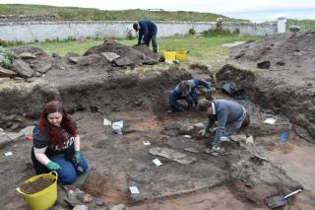

An effort is currently underway to build a historical timeline of events in the history of the Taos Archaeological Society. We need your help if you have records that date in the period September 1999 through February 2014. These dates range between the last completed history for the society and the earliest records archived on our web site.

The Taos Archaeological Society has operated for 34 years. At present documents we have accessible cover under 60 percent of that time. Old bulletins, meeting minutes, financial statements, member lists and other communications of the society will assist in this effort. Please do help if you can. You can send records directly to Paul McGuff (pmcguff@aol.com).

TAS, SMU-Taos and the Picuris Pueblo in Partnership!!!

A New Ceramic Analysis Committee Has been formed!!

Ceramic Sorting and Analysis is getting organized for a pilot project to have analysis conducted on a private take home individual basis to observe Covid-19.

Picuris Analysis Ceramic Sorting is still requesting volunteers to participate in processing out their Prehistoric collections. Contact Mark Henderson for more information. markscotthenderson@gmail.com

Sherder’s ZOOM MEETINGS temporarily suspended.

Zoom Id Number Meeting ID: 878 3989 2686

Taos Black on White
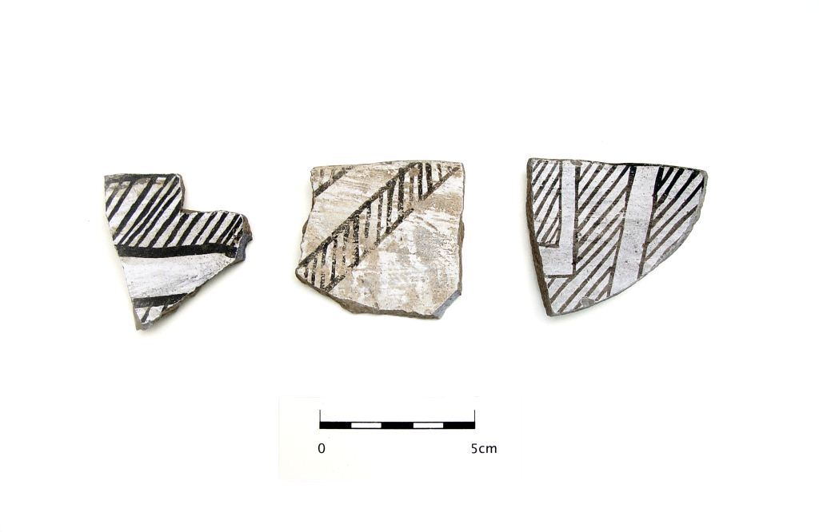
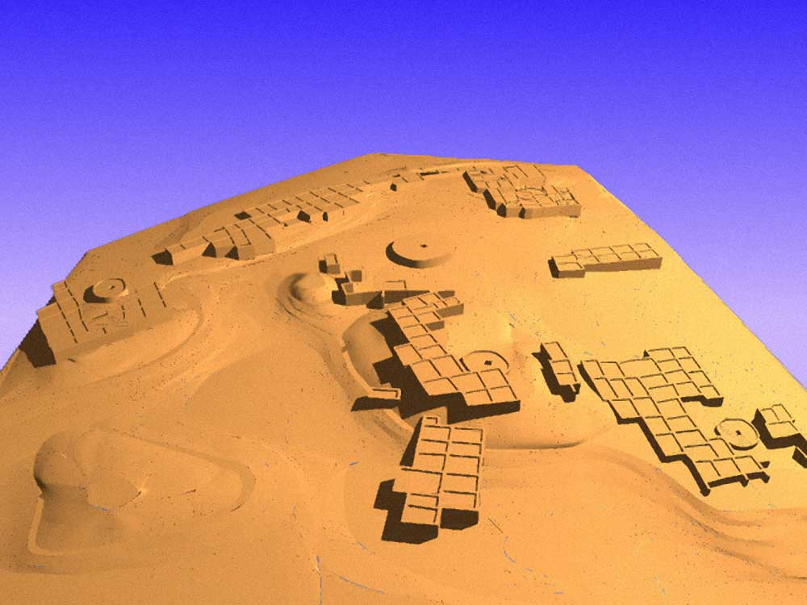

Pot Creek Pueblo 1320 AD

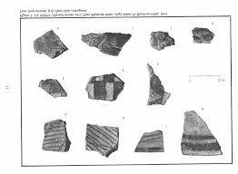
Slate of TAS Officer Elected for 2022-2023
February 1, 2022 until January 31, 2023

Phil Alldritt President
Cassandra Keyes Vice President
Debbie Espie Secretary
Chris Ellis Treasurer

Webmaster (Non Officer position)
Phil Alldritt

The Current Committee Chairs Are as follows:

Education Committee Anita Briscoe

Fieldwork Committee Gary Grief

Newman Dome Subcommittee Cassandra Keyes

Picuris Ceramic Analysis Committee Mark Henderson

Blumenshein Ceramic Analysis Committee For Charter Development
Kurt Weidler/ Jeff Boyer/Becky Quintana/Paul McGuff

Program Committee Cassandra Keyes, Debbie Dean, Phil Alldritt

Trip Committee Paul Reed , Phil Alldrit

Lifetime memberships are possible anytime for TAS. For $500.00 you will receive Lifetime membership plus 1. This can be a spouse or partner. Contact tasorg@hotmail.com if interested. Thank you!

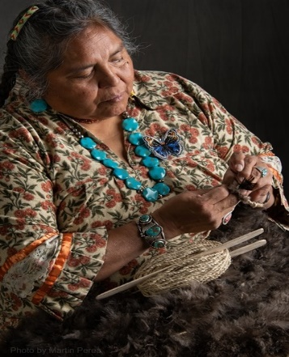
THIS ACTIVITY Has Been Rescheduled for Saturday JUNE 10, 2023
Members already paid are signed up!!!

To the Membership of the Taos Archaeological Society,

On Saturday, June 10, 2023, Mary Motah will conduct a basket and sandal weaving demonstration and hands on workshop for TAS members. The workshop will take place at the Kit Carson Board Room on Cruz Alta Road from 10am-4pm.

The participation is limited to 15 persons. This will fill quickly. Registration based on first 15 payments received. Please include your email to receive a confirmation.

If you miss out we will do this in an ongoing basis. The second 15 payments received will be confirmed to participate in the June 2023 workshop.

The participation fee is $15.00 check or money order made out to Mary Motah. It should be mailed to

Phil Alldritt
PO Box 659
Arroyo Hondo, NM 87513

First 15 deposits received are confirmed. No one is confirmed until payment is received.

Participants should bring a small pocket knife, wear shorts, bring brownbag lunch and drink.

In case of cancellation and you request a refund contact me here.

Thank you for your support and participation in the TAS activities!!

July 31 we had a great turnout for the summer pot luck. More than 60 showed up. Thank you to John and Janet Mockovciak for hosting the party and thanks to Jimmy Stadler for the Great Music!!

WINTER 2022 SUMMER POT LUCK
MONDAY December 5, 2022
Watch your email for further information.

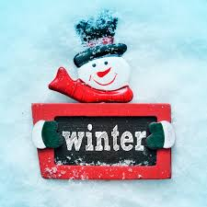

TAKING RESERVATIONS FOR
FALL 2022 and SPRING 2023!!!!!
The Taos Archaeological Society is Funding trips for students to The Mesa Prieta Petroglyph Project!! Trips coming up in Fall 2022 and Spring 2023!!! COVID PERMITTING!!!
Contact Phil Alldritt at taoscuba@hotmail.com

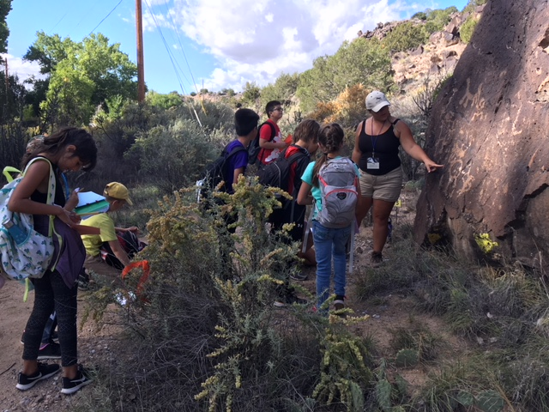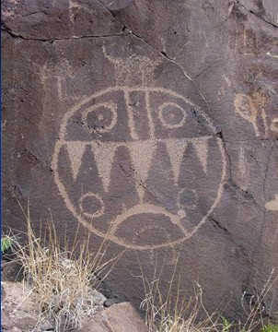

TAS is looking for Members to form an Education Committee who will promote and facilitate communication with teachers and schools to advance our bus trip programs!! To participate in this very successful effort contact Phil Alldritt at taoscuba@hotmail.com
Thank you!!!

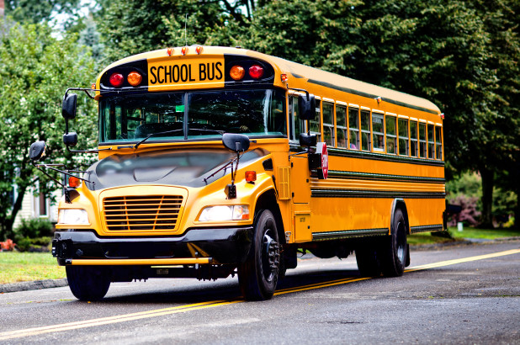

Upcoming Trips
Trip reservations are first come first serve all trips have limited space. No reservation is confirmed until deposits have been made. Watch for future trips on the website!!!
Thank you! COVID PERMITTING!!!
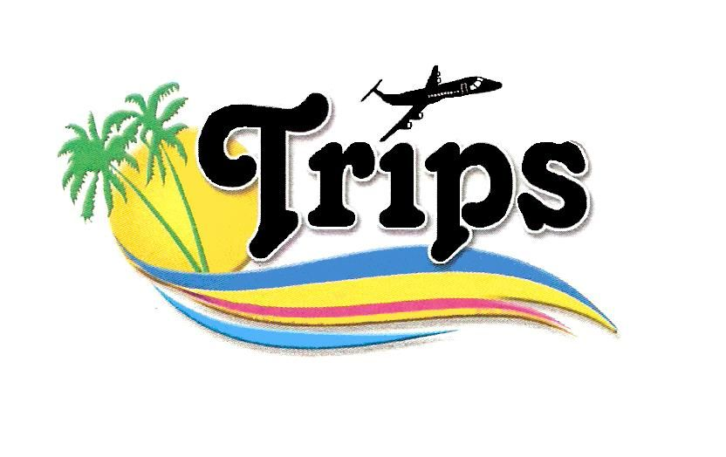All TAS trips may be sign up for by TAS Members who are Active Members in Good Standing. Persons wanting to participate should become Members by mailing 30.00 to
TAS PO Box 143 Taos, NM 87571 Thank you.
NEXT SPEAKER
Monday November 7, 2022
Jonathan Dombrosky
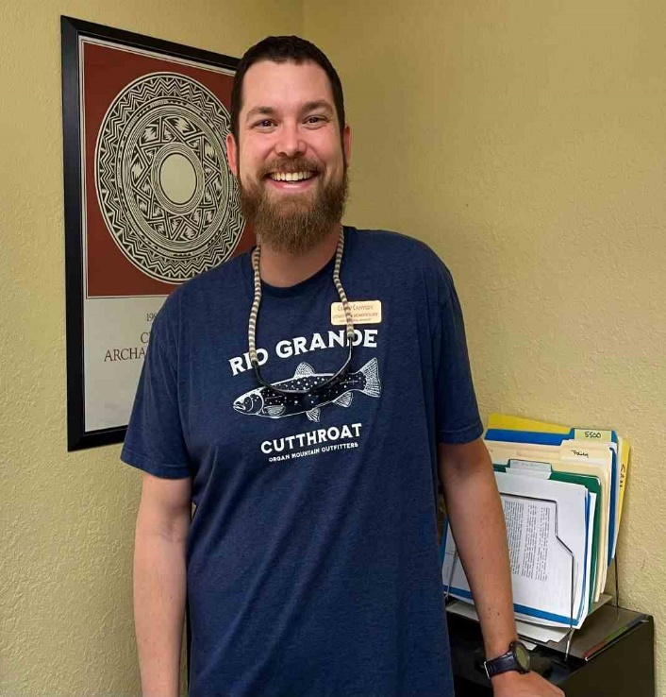

Jonathan is an archaeologist who is broadly interested in human-environment interactions from the past to the present across the globe. He focuses on North American prehistory, specializes in the zooarchaeology of the U.S. Southwest, and uses principles of data science in his research. He received his PhD at the University of New Mexico and is postdoctoral scholar at Crow Canyon Archaeological Center. Jonathan is particularly fascinated by human behavioral ecology, stable isotope ecology, 3D geometric morphometrics, radiocarbon chronology building, and conservation biology.

Title: Down the Rabbit Hole: Testing the Garden Hunting Hypothesis in the Northern U.S. Southwest

Abstract: Garden hunting is the capture of animals from cultivated areas for food, and it is a specific subsistence practice where humans simultaneously use gardens for food production and as animal traps. Here, Jonathan summarizes work where he and a team of researchers use stable isotope analysis to test whether jackrabbits and cottontails fed on the same foods that Ancestral Pueblo people did. He demonstrates how these animals—recovered from the multiple sites—relied on categorically different foods than humans, which raises important questions about the prevalence of garden hunting in the past and what the abundance of jackrabbit and cottontail remains represents. This work highlights the need to more thoroughly understand how farming impacted wild animals in the pre-Hispanic U.S. Southwest, how those impacts altered foraging practices, and how those practices changed or remained constant through time.

Exciting speakers coming all next year in 2023!!!! Watch for the bulletins beginning each month online at taosarch.org for announcements!!!!

.

.

